CSS BRITISH HISTORY · TOPIC 4 · QUESTION ANSWERS
The Industrial and Agricultural Revolutions and the New Society (c.1750–1900)
Every past question on the Industrial Revolution, Methodism, Chartism and the new ideas — answered in full, in simple words, with answer maps

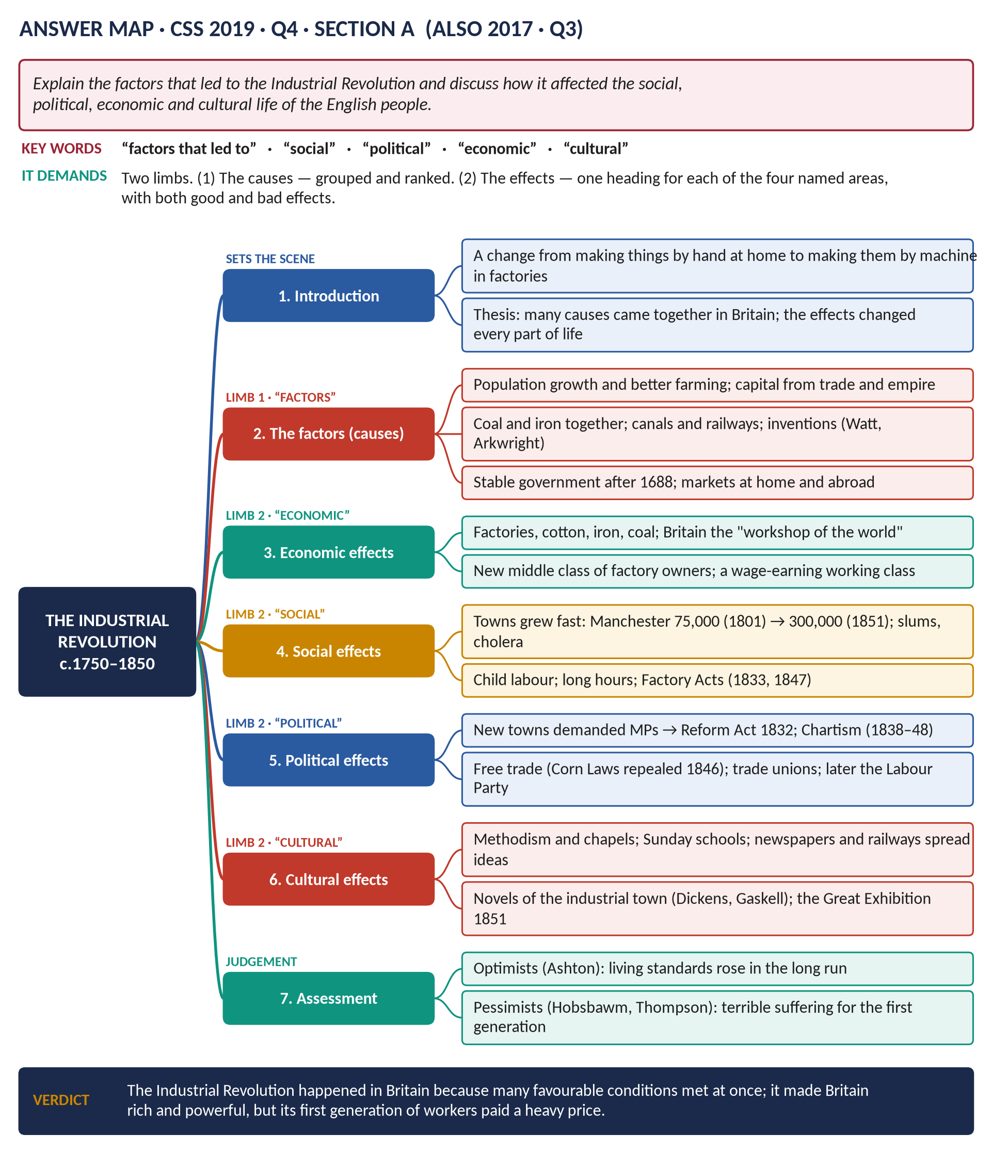
All 14 past items (2015–2026): nine full answers (one shown as an adaptation) and five short notes; the two past MCQs solved; five predicted questions with outlines.
Topic 4 of 10 · companion to T4KB (the Knowledge Base)
Contents
HOW TO USE THIS · Updating the contents
Right-click the contents → Update Field → Update entire table, before saving as PDF.

How to Use These Answers 6
Answer 1 · The Industrial Revolution: Its Causes and Its Effects 7
The model answer 9
Introduction 9
(1) The factors that led to the Industrial Revolution 9
(2) The economic effects 10
(3) The social effects 11
(4) The political effects 11
(5) The cultural effects 11
(6) Assessment: better or worse? 11
Answer 2 · The Effects of the Industrial Revolution on English Life 13
How to adapt Answer 1 13
Answer 3 · Two Movements, Agrarian and Industrial, Revolutionised English Lives 14
The model answer 15
Introduction 15
(1) The Agrarian Revolution 15
(2) The Industrial Revolution 16
(3) How the two movements were linked 16
(4) How they revolutionised English lives 16
(5) How they later changed the world 17
(6) Was it really a "revolution"? 17
Answer 4 · Disruption or Progress? The Industrial Revolution in the Regions 18
The model answer 19
Introduction 19
(1) Disruption: jobs and skills destroyed 20
(2) Disruption: towns, health and family 20
(3) Progress: wealth, jobs and goods 20
(4) Progress: reform and rights 20
(5) What the historians say 20
(6) Weighing the extent 21
Answer 5 · The Emergence of Methodism and Its Good and Bad Effects 22
The model answer 23
Introduction 23
(1) Why Methodism emerged 23
(2) How Methodism emerged 23
(3) The good effects on the people 24
(4) The bad effects on the people 24
(5) Judgement — the Halévy debate 24
Answer 6 · Methodism: Its Beginning, Its Features and Its Success 26
The model answer 27
Introduction 27
(1) How Methodism began 27
(2) Its salient features 27
(3) The reasons for its success 28
(4) A note of balance 28
Answer 7 · The Chartist Movement: An Account and Why It Failed 30
The model answer 31
Introduction 31
(1) Why Chartism arose 31
(2) The Charter 31
(3) Leaders and methods 32
(4) The three petitions 32
(5) Why Chartism failed 32
(6) Did Chartism really fail? 33
Answer 8 · Why Millions Supported the Chartist Movement 35
The model answer 36
Introduction 36
(1) Political reasons 36
(2) Economic reasons 36
(3) Social reasons 37
(4) Organisation, leaders and the Charter 37
(5) Why so many different people united 37
Answer 9 · Socialism and Liberalism in Nineteenth-Century Britain 38
The model answer 39
Introduction 39
(1) What each ideology meant 39
(2) On economic inequality 40
(3) On social justice 40
(4) On the role of the state 40
(5) Similarities 40
(6) How both changed — the meeting point 41
Short Notes 42
The Industrial Revolution 42
The Methodist Movement 42
The Methodist Movement (set again) 43
Fabianism 43
Utilitarianism 44
Part Two — The Past MCQs, Solved 45
CSS 2025 · MCQ 6 45
CSS 2025 · MCQ 7 45
Part Three — Five Predicted Questions, with Outlines 46
Predicted 1 · "Discuss the causes and consequences of the Agricultural Revolution in England." 46
Predicted 2 · "Why did the British state begin to intervene in factories and towns in the first half of the 19th century?" 46
Predicted 3 · "Assess the influence of Utilitarianism on nineteenth-century British reform." 46
Predicted 4 · "Trace the growth of trade unionism in Britain from the Combination Acts to the formation of the Labour Party." 47
Predicted 5 · "'Methodism saved England from revolution.' Discuss." 47

How to Use These Answers
# | Paper | Question (short) | Answer
1 | 2019 Q4 | Factors behind the Industrial Revolution; its social, political, economic and cultural effects | Answer 1
2 | 2017 Q3 | Effects of the Industrial Revolution on four areas — how to reuse Answer 1 | Answer 2
3 | 2018 Q3 | "Two movements (Agrarian and Industrial) revolutionised lives" — comment | Answer 3
4 | 2026 Q3 | Disruption or progress? With regional examples | Answer 4
5 | 2015 P-II Q3 | Emergence of Methodism; its good and bad effects | Answer 5
6 | 2024 Q4 | How Methodism began; its features; reasons for success | Answer 6
7 | 2017 Q4 | Chartism: a full account; why it failed | Answer 7
8 | 2024 Q3 | Why millions supported Chartism | Answer 8
9 | 2025 Q5 | Socialism and Liberalism compared | Answer 9
10 | 2015 P-I Q8(a) | Short note: the Industrial Revolution | Short note
11 | 2015 P-I Q8(b) · 2025 Q8(b) | Short note: the Methodist Movement (set twice) | Short note
12 | 2016 Q8(c) | Short note: Fabianism | Short note
13 | 2022 Q8(c) | Short note: Utilitarianism | Short note

Every answer has: the question as set · its answer map · decoding the question (what the examiner wants, in plain words) · a model answer with numbered headings, a figure and a verdict · why this answer scores.
TRAP — DO NOT FALL INTO IT · One body of knowledge, many angles
The Industrial Revolution has been asked five times, but never in the same way: causes and effects (2019), effects only (2017), two revolutions together (2018), disruption or progress (2026), and a short note (2015). Methodism has been asked as emergence and effects (2015) and as beginning, features and success (2024). Learn the facts once (T4KB); build the headings fresh from each question's own words.

HOW TO USE THIS · If you are new to this topic
Read T4KB Part Zero and Part One first — the ABC and the story. Every answer below assumes only what is explained there. Hard words are explained inside the answers too.

Answer 1 · The Industrial Revolution: Its Causes and Its Effects
THE QUESTION · CSS 2019 · Q4 · Section A · 20 marks
Explain the factors that led to the Industrial Revolution and discuss how it affected the social, political, economic and cultural life of the English people.

Figure 1 · The answer map for CSS 2019 · Q4 · Section A: every branch is one heading of the answer below.
DECODING THE QUESTION
The question has two limbs. "Explain the factors that led to" = the causes: why did it happen, and why in Britain? "Discuss how it affected" = the effects — and the examiner has named four areas: social, political, economic and cultural. Give each its own heading, in that order or a logical one. "Discuss" means show good and bad sides, and end with a judgement.

The model answer

Introduction
The Industrial Revolution was the great change, between about 1750 and 1850, from making goods by hand at home to making them by machine in factories, powered first by water and then by steam and coal. Britain was the first country in the world to go through it. It happened because many favourable conditions came together in eighteenth-century Britain at the same time; and it changed every part of English life — how people worked, where they lived, how they were governed and what they believed.

(1) The factors that led to the Industrial Revolution
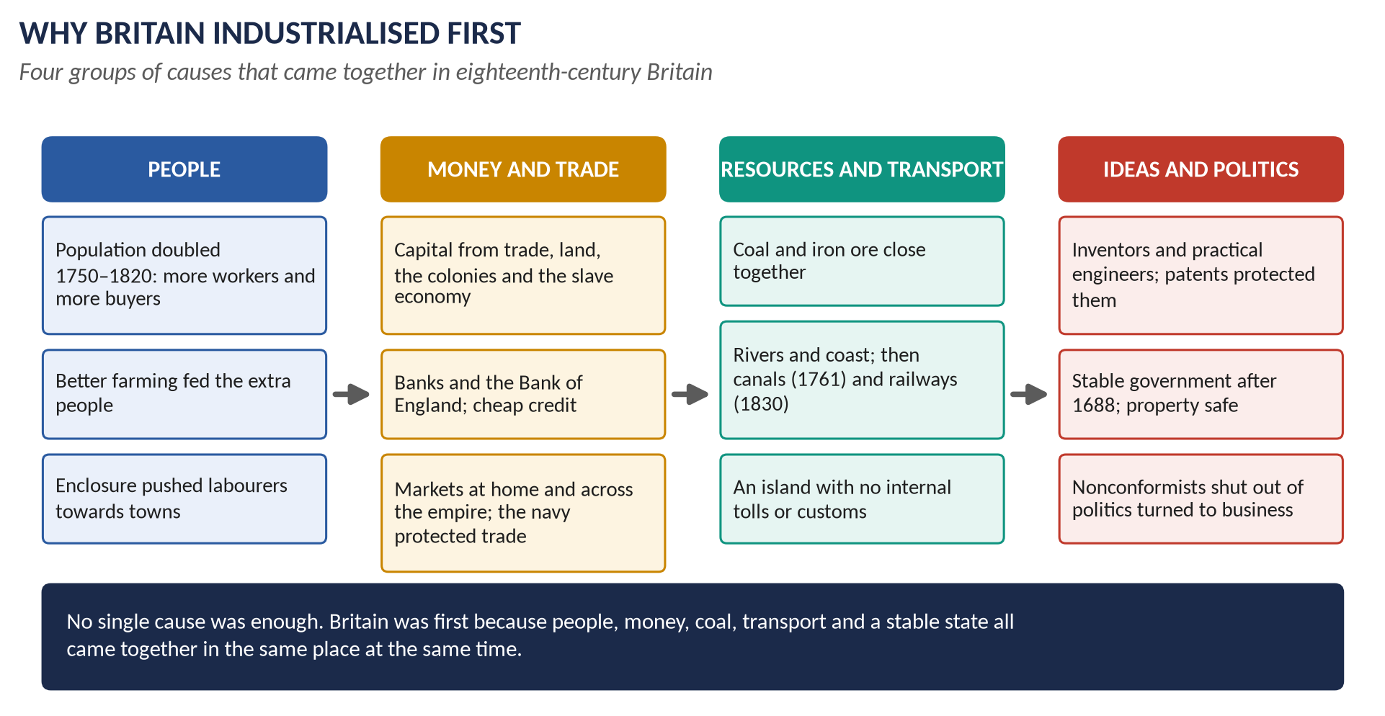
Figure 2 · Why Britain industrialised first: four groups of causes.

(a) A growing population
England and Wales grew from about 6 million people in 1750 to 8.9 million at the first census of 1801 and 17.9 million by 1851. More people meant more workers for the factories and more buyers for their goods.

(b) The Agricultural Revolution
New farming — enclosure of the open fields, Townshend's turnips and clover, Tull's seed drill, Bakewell's breeding — produced much more food, so a larger population could be fed. It also pushed poor cottagers off the land and towards the towns, where they became factory workers.

(c) Capital — money to invest
Britain was rich from overseas trade, from its colonies, from the slave-based sugar trade and from farming. Banks — the Bank of England (1694) and hundreds of country banks — lent money. Landowners and merchants had money to build mills, mines and canals.

(d) Coal and iron, close together
Britain had rich coalfields, often next to iron ore and near rivers or the sea. Abraham Darby smelted iron with coke at Coalbrookdale in 1709; coal fed the steam engines.

(e) Transport
No part of Britain is far from the sea or a navigable river. The Bridgewater Canal (1761) halved the price of coal in Manchester and began a canal boom; the Liverpool and Manchester Railway (1830) began the railway age. There were no internal tolls, so goods moved freely.

(f) Inventions
A chain of inventions solved one problem after another: Kay's flying shuttle (1733), Hargreaves's spinning jenny (c.1764), Arkwright's water frame (1769), Crompton's mule (1779), Cartwright's power loom (1785) — and above all James Watt's improved steam engine (1769), which could drive machines anywhere.

(g) Markets at home and abroad
A growing home market, and a huge overseas market in the colonies, protected by the strongest navy in the world.

(h) A stable government and society
After 1688 Britain had a stable government, safe property, and laws that protected contracts and patents. Nonconformists, barred from Parliament and the universities, put their energy into business.
KEY IDEA · Weighing the factors
No single factor is enough. Other countries had coal, or trade, or inventors; Britain had all of them at once. That combination is why it came first.

(2) The economic effects
- Britain became the "workshop of the world": by 1850 it made about half the world's iron and cotton cloth.
- The factory system replaced the domestic system: work moved from the cottage to the mill, with fixed hours, the clock and wages.
- New industries and regions: cotton in Lancashire, wool in Yorkshire, iron in the Black Country and South Wales, coal in the North-East, ships on the Clyde.
- New classes: a rich middle class of factory owners and merchants; a large working class living on wages.
- Winners and losers: the owners prospered; the handloom weavers, whose skill was replaced by the power loom, were ruined.

(3) The social effects
- Towns grew very fast: Manchester from about 75,000 (1801) to 300,000 (1851). The 1851 census showed that more people lived in towns than in the countryside — the first large country ever to do so.
- Terrible living conditions: crowded back-to-back houses, no clean water or sewers; cholera in 1831–32 and 1848–49.
- Hard working conditions: children of five or six in the mills, twelve-hour days, accidents; women and children underground in mines.
- Reform slowly followed: the Factory Act (1833) with inspectors, the Mines Act (1842), the Ten Hours Act (1847), the Public Health Act (1848).

(4) The political effects
- The middle class demanded a voice: the new towns had no MPs. The Reform Act of 1832 gave them seats and gave middle-class men the vote.
- The working class demanded a voice: Chartism (1838–48) campaigned for votes for all men; later Reform Acts (1867, 1884) granted it.
- Free trade: the Anti-Corn Law League, led by manufacturers, won the repeal of the Corn Laws (1846).
- Trade unions became legal (1824), formed the TUC (1868), and later the Labour Party (1900).
- The state grew: inspectors and boards of health ended pure laissez-faire (the idea that government should not interfere).

(5) The cultural effects
- Religion: Methodism and other chapels spread in the new towns and mining villages; Sunday schools taught millions to read.
- Reading: cheap newspapers, carried by rail; Mechanics' Institutes for workers.
- Literature: novels about the industrial towns — Dickens's Hard Times, Gaskell's Mary Barton, Disraeli's Sybil with its "two nations" of rich and poor.
- A new sense of time: factory hours and "railway time" replaced the rhythm of the seasons.
- Pride: the Great Exhibition of 1851 in the Crystal Palace.

(6) Assessment: better or worse?
Historians disagree. The optimists (T. S. Ashton) argue that industry created jobs and cheaper goods and, in the long run, raised living standards. The pessimists (Hobsbawm, E. P. Thompson, the Hammonds) stress the suffering of the first generation. Modern research (Feinstein) suggests real wages hardly rose until the 1840s, then rose steadily — so both are partly right.
VERDICT · Conclusion
The Industrial Revolution happened in Britain because population, farming, capital, coal, transport, inventions, markets and a stable government all came together. It made Britain the richest and most powerful country in the world and changed every area of life — economic, social, political and cultural. For the first generation of workers the price was very high; for their grandchildren the gains were real and lasting.

WHY THIS ANSWER SCORES · Why this answer scores
Both limbs answered in full · the causes grouped and weighed, not just listed · one heading for each of the four named areas, using the examiner's own words · figures and dates throughout (populations, Manchester, 1833, 1846) · the historians' debate gives a balanced judgement.

Answer 2 · The Effects of the Industrial Revolution on English Life
THE QUESTION · CSS 2017 · Q3 · Section A · 20 marks
The Industrial Revolution drastically changed methods of production in England. How did it affect the social, economic, political and cultural life of the English people?

DECODING THE QUESTION
The full question: "The Industrial Revolution drastically changed methods of production. How did it affect the social, economic, political and cultural life of the English people?" This is Answer 1 without the causes. The opening sentence ("drastically changed methods of production") tells you to begin with the change from hand to machine, from home to factory.

How to adapt Answer 1
1. Introduction: explain "methods of production" — the domestic system (hand-work at home for a merchant) replaced by the factory system (machines, steam power, wage labour in one building). Name the key inventions in one sentence (jenny, water frame, mule, power loom, Watt's steam engine).
2. Skip section (1) of Answer 1 (the causes) — or reduce it to two lines.
3. Use sections (2)–(5) of Answer 1 in full, one heading for each area. Put social first and economic second, to follow the question's order.
4. Give more detail on each area to fill the space the causes took: for social, add the family split by the factory day and the loss of village life; for economic, add the canal and railway booms; for political, add the growth of the state; for cultural, add Methodism and the novels.
5. Keep section (6) (optimists and pessimists) and the verdict.
WHY THIS ANSWER SCORES · Why this works
The examiner asked "how did it affect" four named areas — so the four headings are the answer. Explaining "methods of production" first shows you understood the question's opening statement.

Answer 3 · Two Movements, Agrarian and Industrial, Revolutionised English Lives
THE QUESTION · CSS 2018 · Q3 · Section A · 20 marks
'The 18th century witnessed the emergence, rise and growth of two movements (Agrarian and Industrial) which revolutionised the lives of the English people in particular and later the world in general.' Comment on the statement.

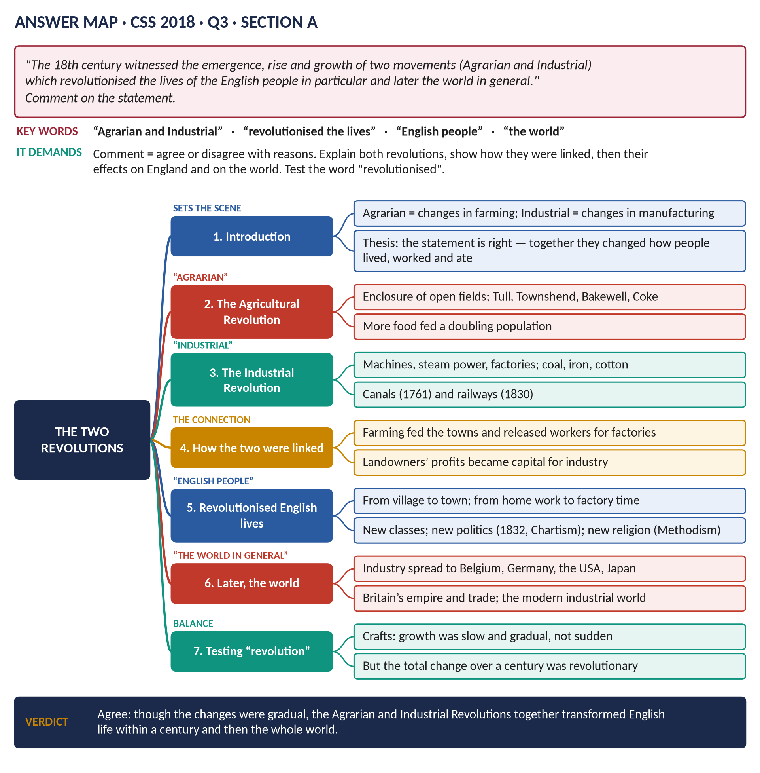
Figure 3 · The answer map for CSS 2018 · Q3 · Section A: every branch is one heading of the answer below.
DECODING THE QUESTION
The full statement: "The 18th century witnessed the emergence, rise and growth of two movements (Agrarian and Industrial) which revolutionised the lives of the English people in particular and later the world in general." "Comment" means say whether you agree, and why. You must explain both revolutions — the Agrarian (farming) as well as the Industrial — show how they were linked, show their effects on England, then on the world, and test the word "revolutionised".

The model answer

Introduction
"Agrarian" means to do with farming and land. In the eighteenth century Britain went through two great changes at the same time: an Agricultural (Agrarian) Revolution, which changed how food was grown, and an Industrial Revolution, which changed how goods were made. The statement is broadly right: together these two movements changed where English people lived, how they worked and what they ate — and Britain's example later spread across the world.

(1) The Agrarian Revolution
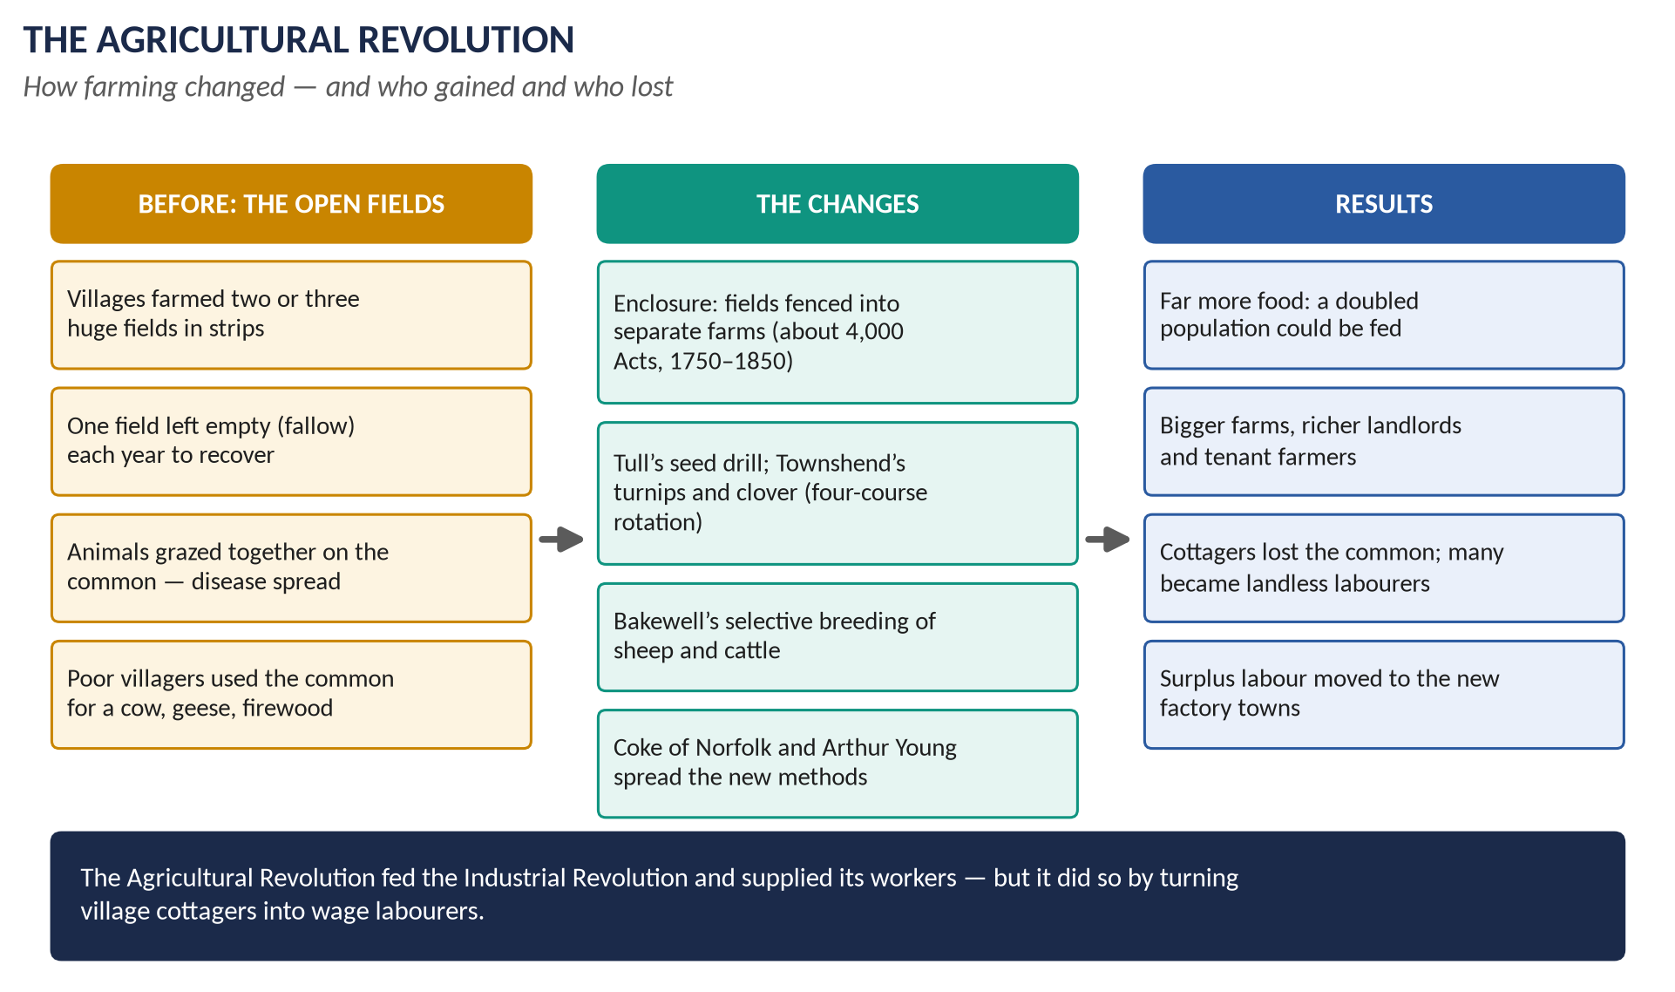
Figure 4 · The Agricultural Revolution: the old way, the changes and the results.

(a) The old way
Villages farmed open fields divided into strips; one field was left fallow (empty) every year; animals grazed on the shared common. It was fair but wasteful.

(b) The changes
- Enclosure: about 4,000 Acts of Parliament (1750–1850) turned open fields and commons into separate, fenced farms.
- New crops: Townshend's turnips and clover and the Norfolk four-course rotation — no more fallow.
- New tools and breeding: Tull's seed drill; Bakewell's bigger sheep and cattle.
- Spreading the ideas: Coke of Norfolk, Arthur Young, the Board of Agriculture (1793).

(c) How it changed lives
Far more food; richer landlords and farmers; but cottagers lost the common and became landless labourers — many moved to the towns.

(2) The Industrial Revolution
- Machines: the spinning jenny, water frame, mule and power loom moved cloth-making from the cottage to the factory.
- Power: Watt's steam engine (1769) and coal.
- Iron: Darby (1709) and Cort (1784).
- Transport: canals (1761) and railways (1830).

(3) How the two movements were linked
1. Food: the Agrarian Revolution fed the growing town population.
2. Workers: it released labour from the land for the factories.
3. Money: landowners' profits were invested in canals, mines and railways.
4. Markets: prosperous farmers bought manufactured goods; industry sent back iron ploughs and, later, machines.
KEY IDEA · One change, two parts
The two revolutions were not separate. The farms fed the factories and supplied their workers; the factories enriched the farms. Together they turned a country of villages into a country of towns.

(4) How they revolutionised English lives
- Where people lived: from village to town — by 1851 more English people lived in towns than in the country.
- How they worked: from their own time on their own strip or loom, to the factory clock and a wage.
- Society: a new middle class and a new working class.
- Politics: the Reform Act of 1832, Chartism, trade unions.
- Religion and ideas: Methodism, Liberalism, Utilitarianism, Socialism.
- Health and hardship: slums, cholera, child labour — then reform.

(5) How they later changed the world
- Industry spread to Belgium, France, Germany and the USA in the nineteenth century, and to Japan after 1868.
- Britain's industrial strength built its empire and made it the centre of world trade and finance.
- The world economy of factories, railways and global markets grew from the British example — so did the modern debate about capitalism and socialism.

(6) Was it really a "revolution"?
Some historians (N. F. R. Crafts) argue that growth was slow and gradual, not sudden; enclosure had begun centuries earlier; many people still worked in small workshops in 1850. But "revolution" describes the scale of the change, not its speed: within about a century the whole way of life was transformed.
VERDICT · Conclusion
The statement is correct. Though each change was gradual, the Agrarian and Industrial Revolutions, working together, transformed English life more deeply than any political revolution — and within a century their effects had spread to the whole world.

WHY THIS ANSWER SCORES · Why this answer scores
It explains both movements (many candidates forget the Agrarian one) · it shows the link between them · it answers "English people" and "the world" separately · it tests the word "revolutionised" — which is what "comment" asks.

Answer 4 · Disruption or Progress? The Industrial Revolution in the Regions
THE QUESTION · CSS 2026 · Q3 · Section A · 20 marks
Critically evaluate the extent to which the Industrial Revolution transformed British society more through disruption than through progress. Use regional examples to support your argument.

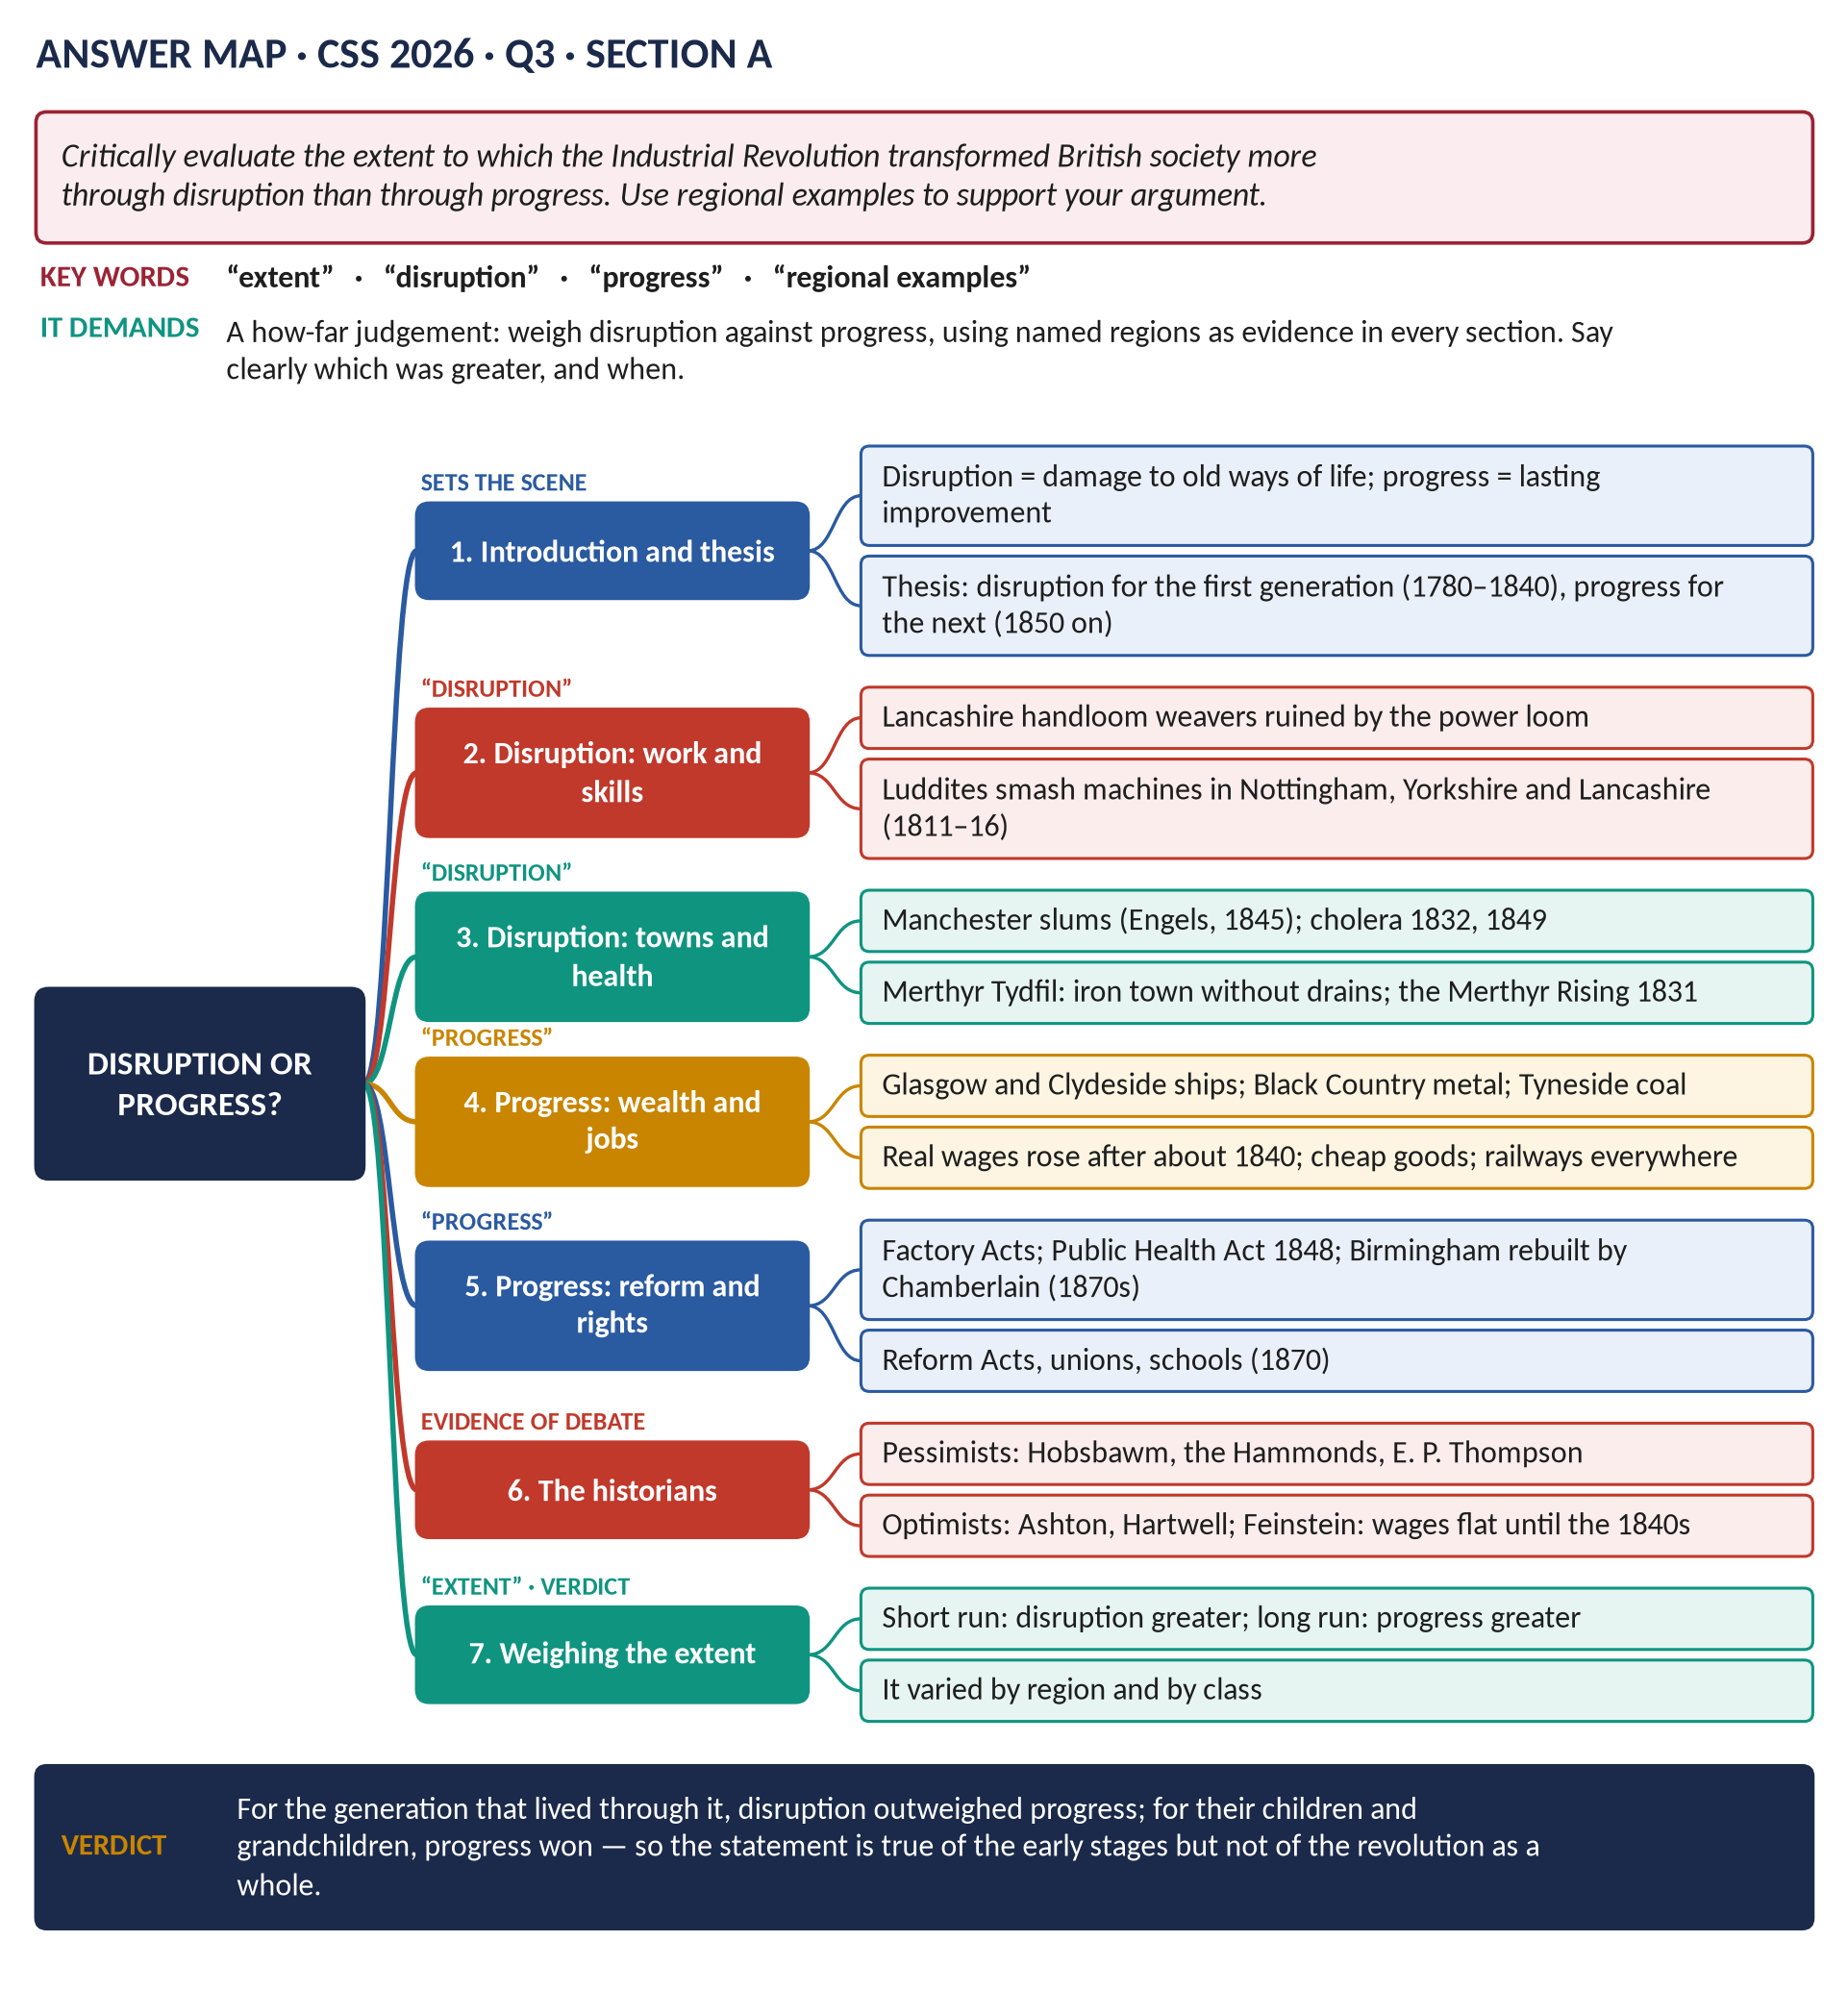
Figure 5 · The answer map for CSS 2026 · Q3 · Section A: every branch is one heading of the answer below.
DECODING THE QUESTION
"Critically evaluate the extent" = a how-far question: you must weigh two things and give a clear judgement. "Disruption" = the damage done to old ways of life (lost jobs, slums, disease, broken families). "Progress" = lasting improvement (wealth, jobs, health, rights). "Use regional examples" is an order: name places — Lancashire, Yorkshire, the Midlands, South Wales, the North-East, Scotland — in every section, not just once.

The model answer

Introduction
The Industrial Revolution changed Britain between about 1750 and 1850. The question is whether it changed society more by disruption — destroying old livelihoods and communities — than by progress — creating wealth and better lives. This answer argues that the balance changed over time: for the first generation (about 1780–1840) disruption was greater; after about 1850 progress clearly outweighed it. It also varied from region to region.
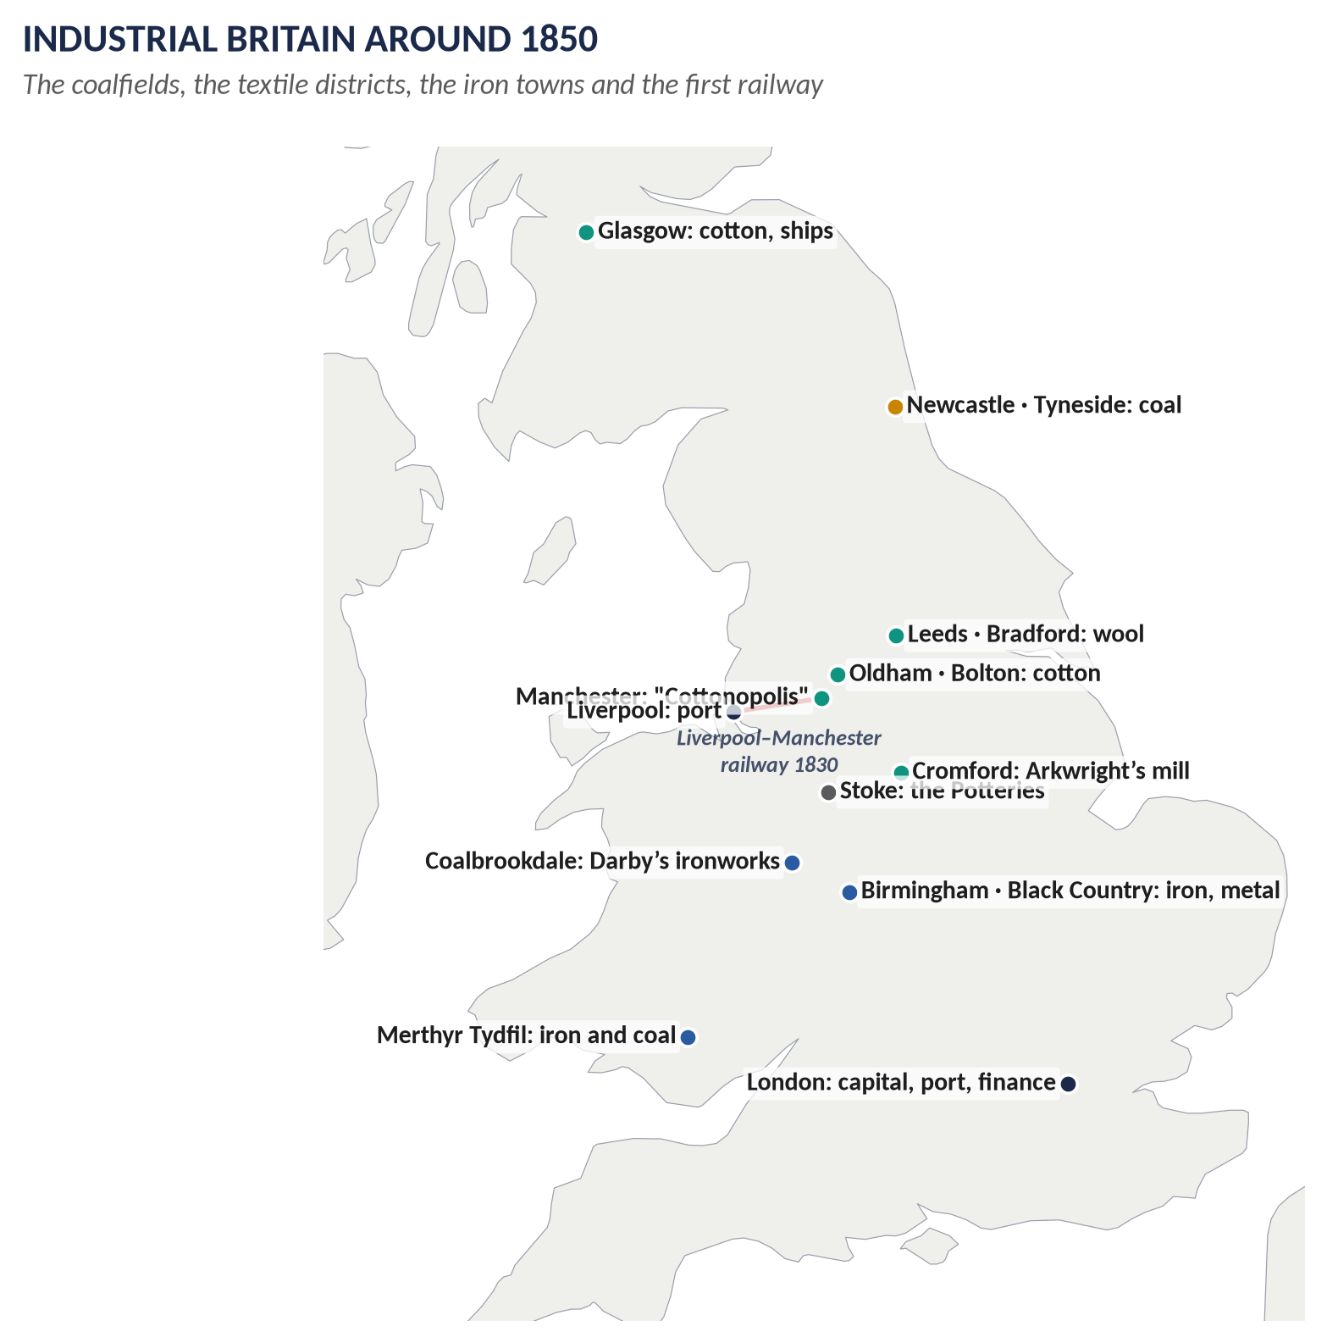
Figure 6 · The industrial regions of Britain around 1850.

(1) Disruption: jobs and skills destroyed
- Lancashire: the handloom weavers, once skilled and well paid, were ruined by the power loom; their wages fell from about 20 shillings a week (1800) to under 6 by the 1830s.
- Nottingham, Yorkshire and Lancashire: the Luddites (1811–16) smashed the machines that were taking their jobs; troops were sent in and machine-breaking was made a capital crime.
- The countryside: enclosure and threshing machines drove southern farm labourers to the Swing Riots (1830).

(2) Disruption: towns, health and family
- Manchester: Engels (1845) described slums of cellars and filth; working people's life expectancy was under 30.
- Merthyr Tydfil (South Wales): the biggest town in Wales, built round ironworks, had no drains or clean water; the Merthyr Rising of 1831 was crushed by soldiers.
- Glasgow: some of the worst slums in Europe; cholera struck again and again.
- Families: children as young as five in the mills of Lancashire and the pits of the North-East; family life broken by the factory day.

(3) Progress: wealth, jobs and goods
- Lancashire's cotton became Britain's greatest export; mill towns grew rich.
- Leeds and Bradford (Yorkshire) became great wool cities; Birmingham the "city of a thousand trades".
- South Wales: the Dowlais ironworks became the largest in the world; Welsh coal fuelled ships worldwide.
- The North-East: the world's first public railway (Stockton and Darlington, 1825); Tyneside engineering.
- The Clyde (Glasgow) became the shipbuilding centre of the world.
- Real wages rose steadily after the 1840s; cheap cotton, soap, tea and sugar; railways let ordinary people travel.

(4) Progress: reform and rights
- Factory Acts (1833, 1847) and the Mines Act (1842) protected children and women.
- The Public Health Act (1848); Birmingham was rebuilt with clean water, gas and parks by Joseph Chamberlain in the 1870s.
- Rights: the Reform Acts (1832, 1867, 1884), legal trade unions, schools for all (1870).
- These reforms were themselves a response to the disruption — progress came partly because people protested against the damage.

(5) What the historians say
- Pessimists — the Hammonds, Hobsbawm, E. P. Thompson — say disruption dominated: workers lost independence, community and health.
- Optimists — Ashton, Hartwell — say progress dominated: industry created the wealth that later raised everyone.
- Feinstein's figures: wages flat until the 1840s, then rising — supporting "disruption first, progress later".

(6) Weighing the extent
Period or group | Disruption | Progress
First generation (to c.1840) | Greater: weavers, Luddites, slums, cholera | Limited to owners and skilled engineers
After c.1850 | Declining: reform, better towns | Greater: rising wages, rights, cheap goods
Old craft regions (Lancashire weavers, Midlands knitters) | Severe | Slow
New industrial regions (Clyde, Tyneside, Birmingham) | Real | Strong

VERDICT · Conclusion
The Industrial Revolution transformed British society more through disruption than progress for those who lived through its early stages — the handloom weavers of Lancashire, the Luddites of Nottingham, the slum-dwellers of Manchester and Merthyr. But the wealth it created, and the reforms that disruption forced, meant that by the second half of the century progress had clearly won. The statement is therefore true of the revolution's first half-century, but not of the revolution as a whole.

WHY THIS ANSWER SCORES · Why this answer scores
It defines both key words · it gives regional examples in every section (Lancashire, Yorkshire, Nottingham, Merthyr, Glasgow, Birmingham, the Clyde, Tyneside) · it uses historians and figures · and it gives a clear, time-based judgement on "the extent" — exactly what "critically evaluate" demands.

Answer 5 · The Emergence of Methodism and Its Good and Bad Effects
THE QUESTION · CSS 2015 · Q3 · Paper II · 20 marks
Describe the emergence of the Methodist Movement in England. What were its good and bad effects on the people?

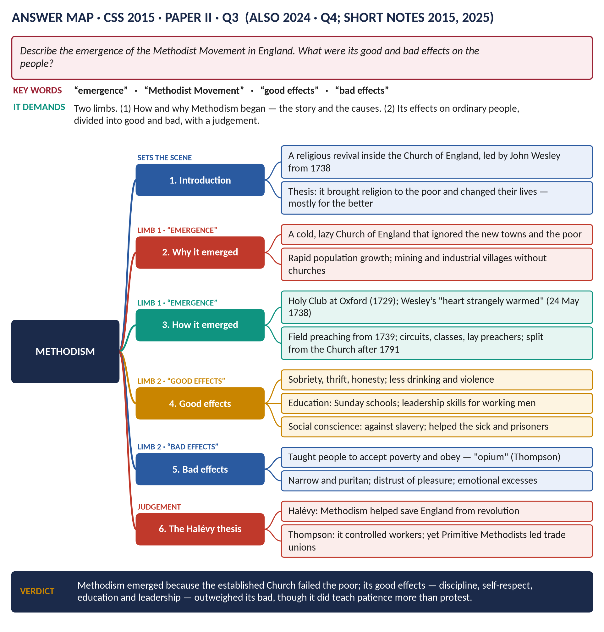
Figure 7 · The answer map for CSS 2015 · Q3 · Paper II: every branch is one heading of the answer below.
DECODING THE QUESTION
Two limbs. "Describe the emergence" = tell the story of how and why Methodism began and grew. "Good and bad effects on the people" = its effects on ordinary English people — give both sides, under separate headings, then a judgement. A beginner's tip: Methodism is a Christian movement, a branch of Protestantism, begun by John Wesley.

The model answer

Introduction
Methodism was a religious revival — a movement to bring new life to Christianity — that began inside the Church of England in the 1730s, led by John Wesley, his brother Charles and George Whitefield. It took a warm, simple Christian message to the poor, above all in the new mining and industrial districts. Its effects on ordinary people were mostly good — sobriety, education, self-respect — although critics say it also taught them to accept their poverty.

(1) Why Methodism emerged

(a) A Church that had grown cold
The Church of England — the official, state church — was comfortable and sleepy. Many clergy were gentlemen who held several parishes (pluralism) and did not live in them (non-residence). Sermons were dry and intellectual, and the poor felt unwelcome.

(b) Churches in the wrong places
The population was growing and moving. New mining villages and industrial towns had no church at all, and no one to care for the people's spiritual needs.

(c) People in need
Poor, uprooted people faced hard work, drink, disease and early death. They wanted comfort, hope and a sense that they mattered.

(2) How Methodism emerged
- 1729 — the Holy Club: at Oxford, John and Charles Wesley and friends met to pray, study the Bible and visit prisoners by strict rules. Other students mocked them as "Methodists" because of their method.
- 24 May 1738 — Wesley's conversion: at a meeting in Aldersgate Street, London, Wesley felt his "heart strangely warmed" and became sure of God's love for him personally. This is taken as the start of Methodism.
- 1739 — field preaching: many churches closed their pulpits to him, so Wesley followed Whitefield and preached in the open air — first to the coal miners of Kingswood near Bristol. Thousands came.
- Organisation: members met weekly in classes of about 12; lay preachers (ordinary people) spread the message; travelling preachers covered circuits; the Conference (from 1744) ran the movement.
- Wesley's travels: about 250,000 miles on horseback and 40,000 sermons in over fifty years.
- Separation: Wesley died in 1791 still a member of the Church of England, but the Methodists soon became a separate church.

(3) The good effects on the people
1. Sobriety and good behaviour: Methodists gave up drunkenness, gambling, swearing and fighting; many families became more stable and better off.
2. Thrift and hard work: they saved money and worked steadily — some rose into the middle class.
3. Education: Methodist Sunday schools taught millions of working-class children to read.
4. Self-respect and leadership: class leaders and lay preachers were ordinary miners, weavers and labourers. They learned to speak in public, organise and lead — skills many later used in trade unions and Chartism.
5. Hope and comfort for people living hard lives.
6. Social conscience: Wesley attacked the slave trade (Thoughts upon Slavery, 1774) and cared for the sick, prisoners and the poor.

(4) The bad effects on the people
1. Acceptance of poverty: critics say it taught the poor to put up with their suffering and wait for reward in heaven, rather than fight for better conditions.
2. Obedience to employers: some employers welcomed it because it made workers disciplined and obedient.
3. Narrowness: it disapproved of dancing, theatre, fairs and many popular pleasures.
4. Emotional excess: some meetings produced shouting, fainting and hysteria.
5. Division: after 1791 it split into several rival groups.

(5) Judgement — the Halévy debate
The French historian Élie Halévy argued that Methodism saved England from a revolution like France's, by turning anger into religion. E. P. Thompson agreed that it controlled workers, calling it a "chiliasm of despair". But many trade union leaders were Methodists — George Loveless, one of the Tolpuddle Martyrs (1834), was a Methodist lay preacher — so Methodism also taught people how to organise for their rights.
VERDICT · Conclusion
Methodism emerged because the Church of England had failed the poor of a changing, growing country, and because John Wesley took religion to them with extraordinary energy and organisation. Its good effects — sober, educated, self-respecting and organised working people — outweighed its bad effects, although it did teach patience more readily than protest.

WHY THIS ANSWER SCORES · Why this answer scores
The emergence is told as both causes and story · good and bad effects are in separate numbered lists · dates and names throughout (1729, 1738, 1739, 1744, 1791) · the Halévy debate turns description into a judgement.

Answer 6 · Methodism: Its Beginning, Its Features and Its Success
THE QUESTION · CSS 2024 · Q4 · Section A · 20 marks
How did the Methodist Movement begin? Also explain its salient features and reasons for success.

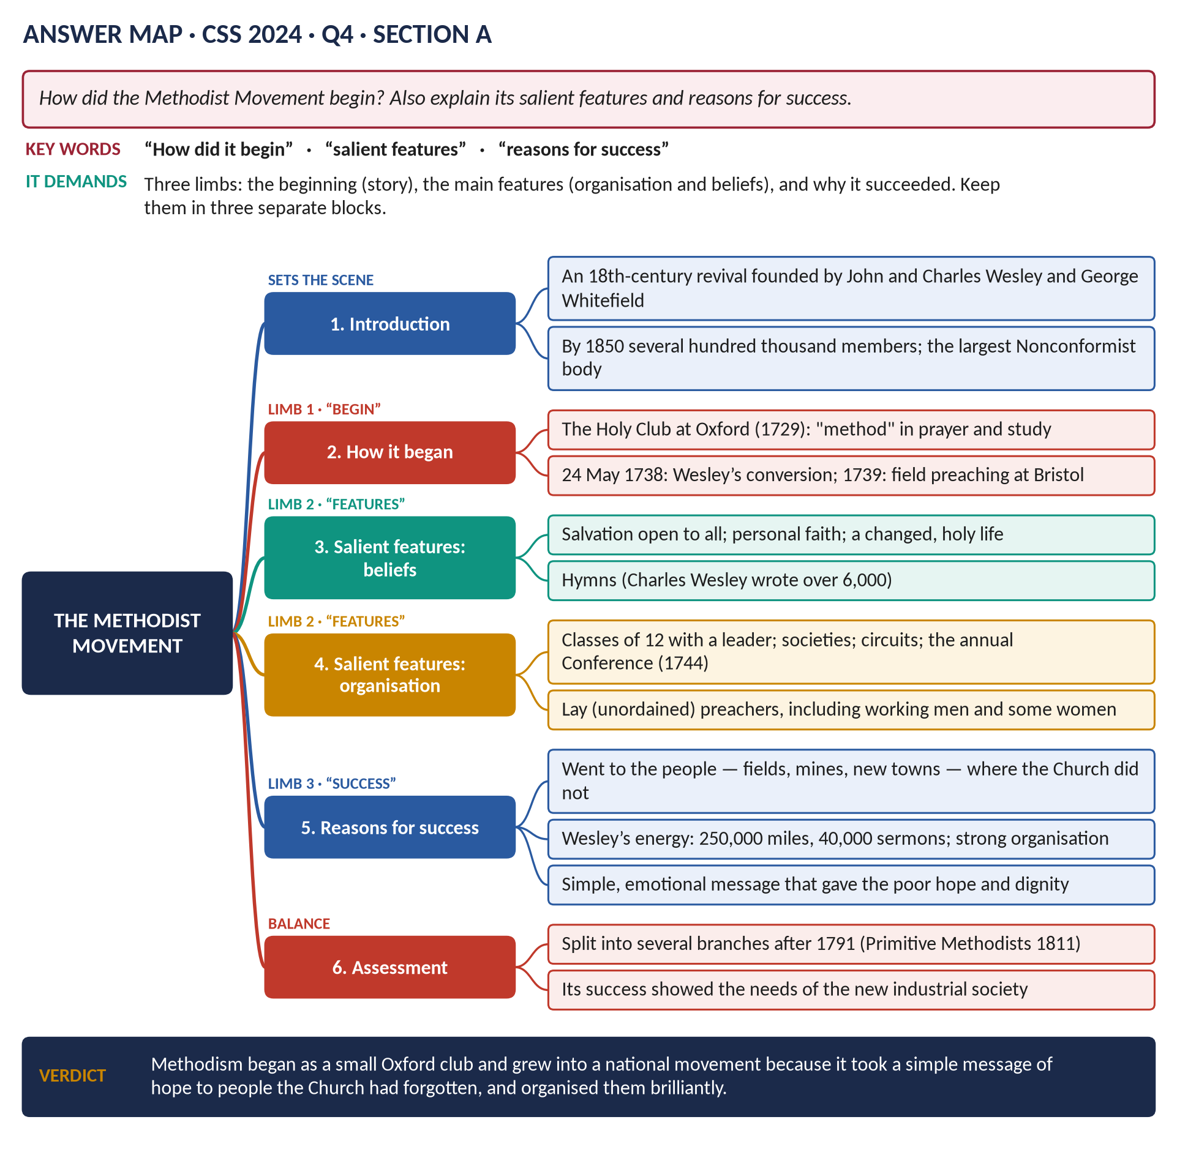
Figure 8 · The answer map for CSS 2024 · Q4 · Section A: every branch is one heading of the answer below.
DECODING THE QUESTION
Three limbs, three blocks: (1) "How did it begin" — the story; (2) "salient features" — its main characteristics: beliefs, organisation, worship ("salient" simply means main or most noticeable); (3) "reasons for success" — why it grew so large. Do not spend long on effects — they were not asked.

The model answer

Introduction
Methodism was an eighteenth-century Christian revival founded by John Wesley (1703–91) with his brother Charles and George Whitefield. Beginning as a small student club at Oxford, it grew into the largest Nonconformist church in England, with about 72,000 members at Wesley's death and several hundred thousand by 1850. It succeeded because it took a simple message of hope to people whom the Church of England had neglected, and organised them brilliantly.

(1) How Methodism began

(a) The background
The Church of England was lazy and remote: clergy held several parishes and lived away from them; new industrial and mining areas had no churches; the poor were ignored.

(b) The Holy Club (1729)
At Oxford, the Wesley brothers formed a small group that prayed, fasted, studied the Bible and visited prisoners by strict method — hence the nickname "Methodists".

(c) Wesley's conversion (1738)
After a failed mission to Georgia in America, John Wesley attended a meeting at Aldersgate Street, London, on 24 May 1738, where he felt his "heart strangely warmed". From then on he preached that anyone could feel God's love personally.

(d) Field preaching (1739)
Refused by many churches, Wesley followed Whitefield and preached in the open air to the miners of Kingswood near Bristol. Huge crowds came, and the movement spread across the country.

(2) Its salient features

(a) Beliefs
- Salvation for all: God's love is open to everyone — rich or poor — not just a chosen few.
- Personal faith: a felt experience of being forgiven.
- Holy living: a changed life afterwards — no drink, gambling or swearing; honesty and hard work.

(b) Organisation
- Classes of about 12 members with a leader, meeting weekly to pray and check each other's progress.
- Societies in each place, grouped into circuits served by travelling preachers.
- Lay preachers: ordinary men — and some women — who were not ordained priests.
- The annual Conference (from 1744) governed everything; the Deed of Declaration (1784) gave it legal control.

(c) Worship
- Open-air preaching in fields and market-places, then simple chapels.
- Hymn singing: Charles Wesley wrote over 6,000 hymns.
- Warm, emotional, lively services.

(d) Social work
Visiting the sick and prisoners; schools; cheap books; Wesley's opposition to slavery (1774).

(3) The reasons for its success
1. It went to the people: to the fields, mines and new towns where the Church of England was absent.
2. A simple, hopeful message: every person matters to God — powerful for people who felt they mattered to no one.
3. Dignity and responsibility: ordinary people could be class leaders and preachers.
4. Excellent organisation: classes, circuits and Conference kept members together and disciplined.
5. Wesley's energy and long life: 250,000 miles and 40,000 sermons over more than fifty years.
6. The hymns: easy to learn and sing, they taught the faith.
7. The needs of a changing society: uprooted people in growing industrial areas were looking for community and meaning.

(4) A note of balance
Success brought division: after Wesley's death the Methodists separated from the Church of England (1795) and later split into branches such as the Primitive Methodists (1811), who were strong among miners and farm labourers.
VERDICT · Conclusion
Methodism began with a small Oxford club and one man's religious experience, and became a national movement because its features — a simple message, personal faith, strong organisation and lay leadership — exactly met the needs of ordinary people in a changing, industrialising England.

WHY THIS ANSWER SCORES · Why this answer scores
Three limbs, three blocks, each with the examiner's word as its heading · "salient features" broken into beliefs, organisation, worship and social work · the reasons for success are numbered and specific · dates throughout.

Answer 7 · The Chartist Movement: An Account and Why It Failed
THE QUESTION · CSS 2017 · Q4 · Section A · 20 marks
Give a comprehensive account of the Chartist Movement. Why did it fail? Explain and analyse.


Figure 9 · The answer map for CSS 2017 · Q4 · Section A: every branch is one heading of the answer below.
DECODING THE QUESTION
Two limbs. "Give a comprehensive account" = tell the whole story: what Chartism was, why it arose, its Charter, its leaders, its methods and its three petitions. "Why did it fail? Explain and analyse" = list the causes of failure and weigh them — which mattered most? A strong answer adds that most of its aims were later won.

The model answer

Introduction
Chartism was the first mass working-class political movement in history. Between 1838 and 1848 millions of British workers campaigned for the People's Charter, a list of six demands whose centre was the vote for every man. Chartism failed at the time — Parliament rejected its petitions three times — because it was divided, faced a strong and united state, and lost support whenever times improved. Yet within seventy years almost all its demands had become law.

(1) Why Chartism arose
- The "great betrayal" of 1832: workers had campaigned for the Reform Act, but it gave the vote only to middle-class men. About four men in five still had no vote.
- The New Poor Law (1834): the poor who asked for help were forced into harsh workhouses — called "Bastilles" after the French prison.
- Hard times: a deep depression in 1837–42 brought unemployment and hunger; the Corn Laws kept bread dear.
- Factory grievances and the transportation of the Tolpuddle Martyrs (1834) for forming a union.

(2) The Charter
Drawn up in May 1838 by William Lovett of the London Working Men's Association (with the help of Francis Place).
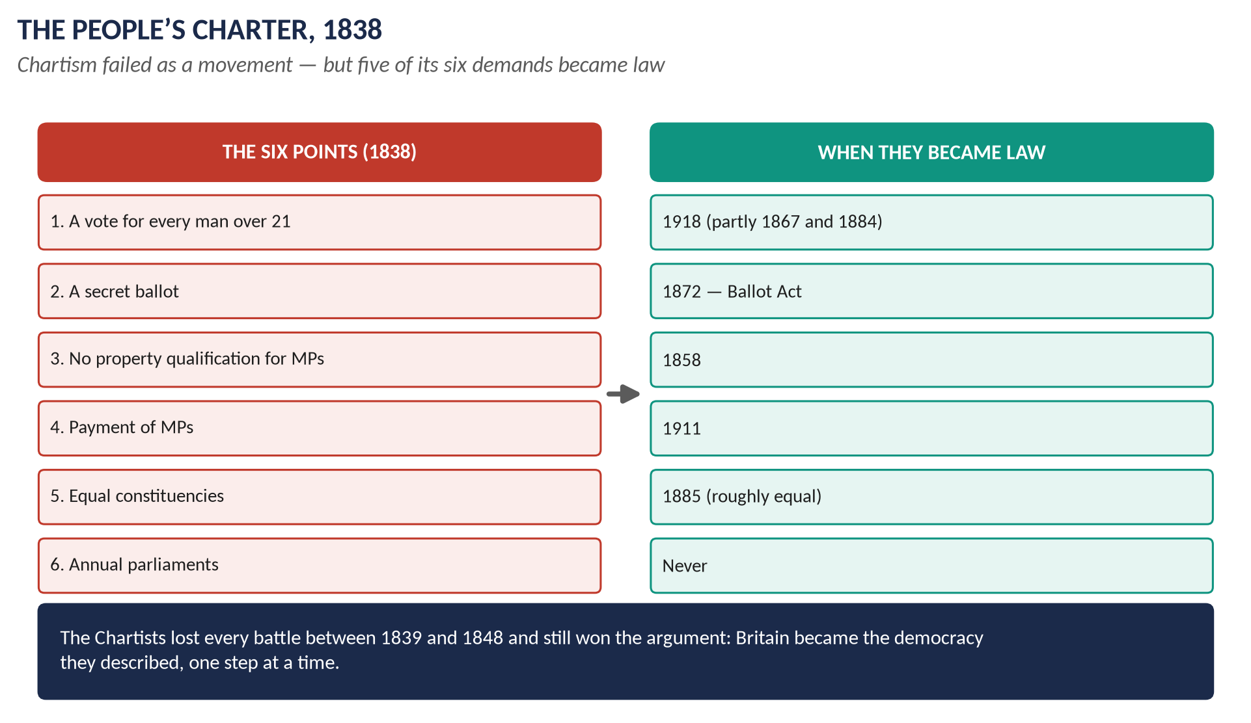
Figure 10 · The six points of the People's Charter, and when each became law.

(3) Leaders and methods
- William Lovett — "moral force": win by education, argument and peaceful petition.
- Feargus O'Connor — a fiery Irish speaker who ran the Northern Star newspaper (1837) and sometimes spoke of "physical force" if Parliament refused.
- Methods: mass meetings, torchlight processions, a national Convention (1839), and giant petitions to Parliament.

(4) The three petitions
Year | Signatures | What happened
1839 | about 1.3 million | Rejected by 235 votes to 46. In November the Newport Rising in Wales: soldiers killed about 22; the leader John Frost was transported
1842 | about 3.3 million | Rejected by 287 to 49. The "Plug Plot" strikes across the north — workers pulled the plugs from factory boilers
1848 | claimed 5.7 million; about 2 million genuine | The great meeting at Kennington Common, London (10 April); the government prepared troops and 85,000 special constables; the petition contained fake names ("Queen Victoria", "Mr Punch") and was laughed out

(5) Why Chartism failed

(a) Divided leadership and methods
Lovett's moral force and O'Connor's physical force quarrelled; O'Connor fell out with almost everyone; his Land Plan (to settle workers on smallholdings) collapsed. A divided movement could not act together.

(b) A strong and united state
The government used the army (General Napier in the north), the new police, and the new railways and electric telegraph to move troops quickly. The landed aristocracy and the middle class stood together against it.

(c) Middle-class hostility
After 1832 the middle class had the vote and did not want to share it. Middle-class reformers backed the Anti-Corn Law League instead, which was richer and better organised.

(d) Economic recovery
Chartism was strongest in bad years (1839, 1842, 1848) and faded whenever trade improved; the railway boom of the 1840s brought jobs. "Knife-and-fork" (hunger) support did not last.

(e) Reforms removed grievances
The Mines Act (1842), the repeal of the Corn Laws (1846) and the Ten Hours Act (1847) showed that Parliament could help workers without giving them votes.

(f) No way to force Parliament
Parliament simply voted the petitions down. Without violence — which most Chartists would not use — the movement had no other weapon.
KEY IDEA · Which cause mattered most?
The decisive reason was the strength and unity of the state and the propertied classes: faced with a government ready to use force and a Parliament that would not listen, a divided movement of the voteless had no way to win. Economic recovery then drained away its mass support.

(6) Did Chartism really fail?
In the long run, no. Five of the six points became law: no property qualification for MPs (1858), the secret ballot (1872), roughly equal constituencies (1885), payment of MPs (1911), and votes for all men (1918). Only annual parliaments never came. Chartism also taught working people to organise and passed its experience to the trade unions and, later, the Labour Party.
VERDICT · Conclusion
Chartism failed because it was divided, faced a strong and united ruling class, and lost its followers whenever times improved. But it failed only in the short term: its programme became the blueprint of British democracy.

WHY THIS ANSWER SCORES · Why this answer scores
The account is truly "comprehensive" — causes, Charter, leaders, methods, all three petitions with figures · the failure is explained under separate headings and analysed (the key box ranks the causes) · the long-term success gives balance and a strong ending.

Answer 8 · Why Millions Supported the Chartist Movement
THE QUESTION · CSS 2024 · Q3 · Section A · 20 marks
Describe the reasons due to which millions of people united in support of the Chartist Movement in the mid-19th century to attain democratic rights for the working classes.

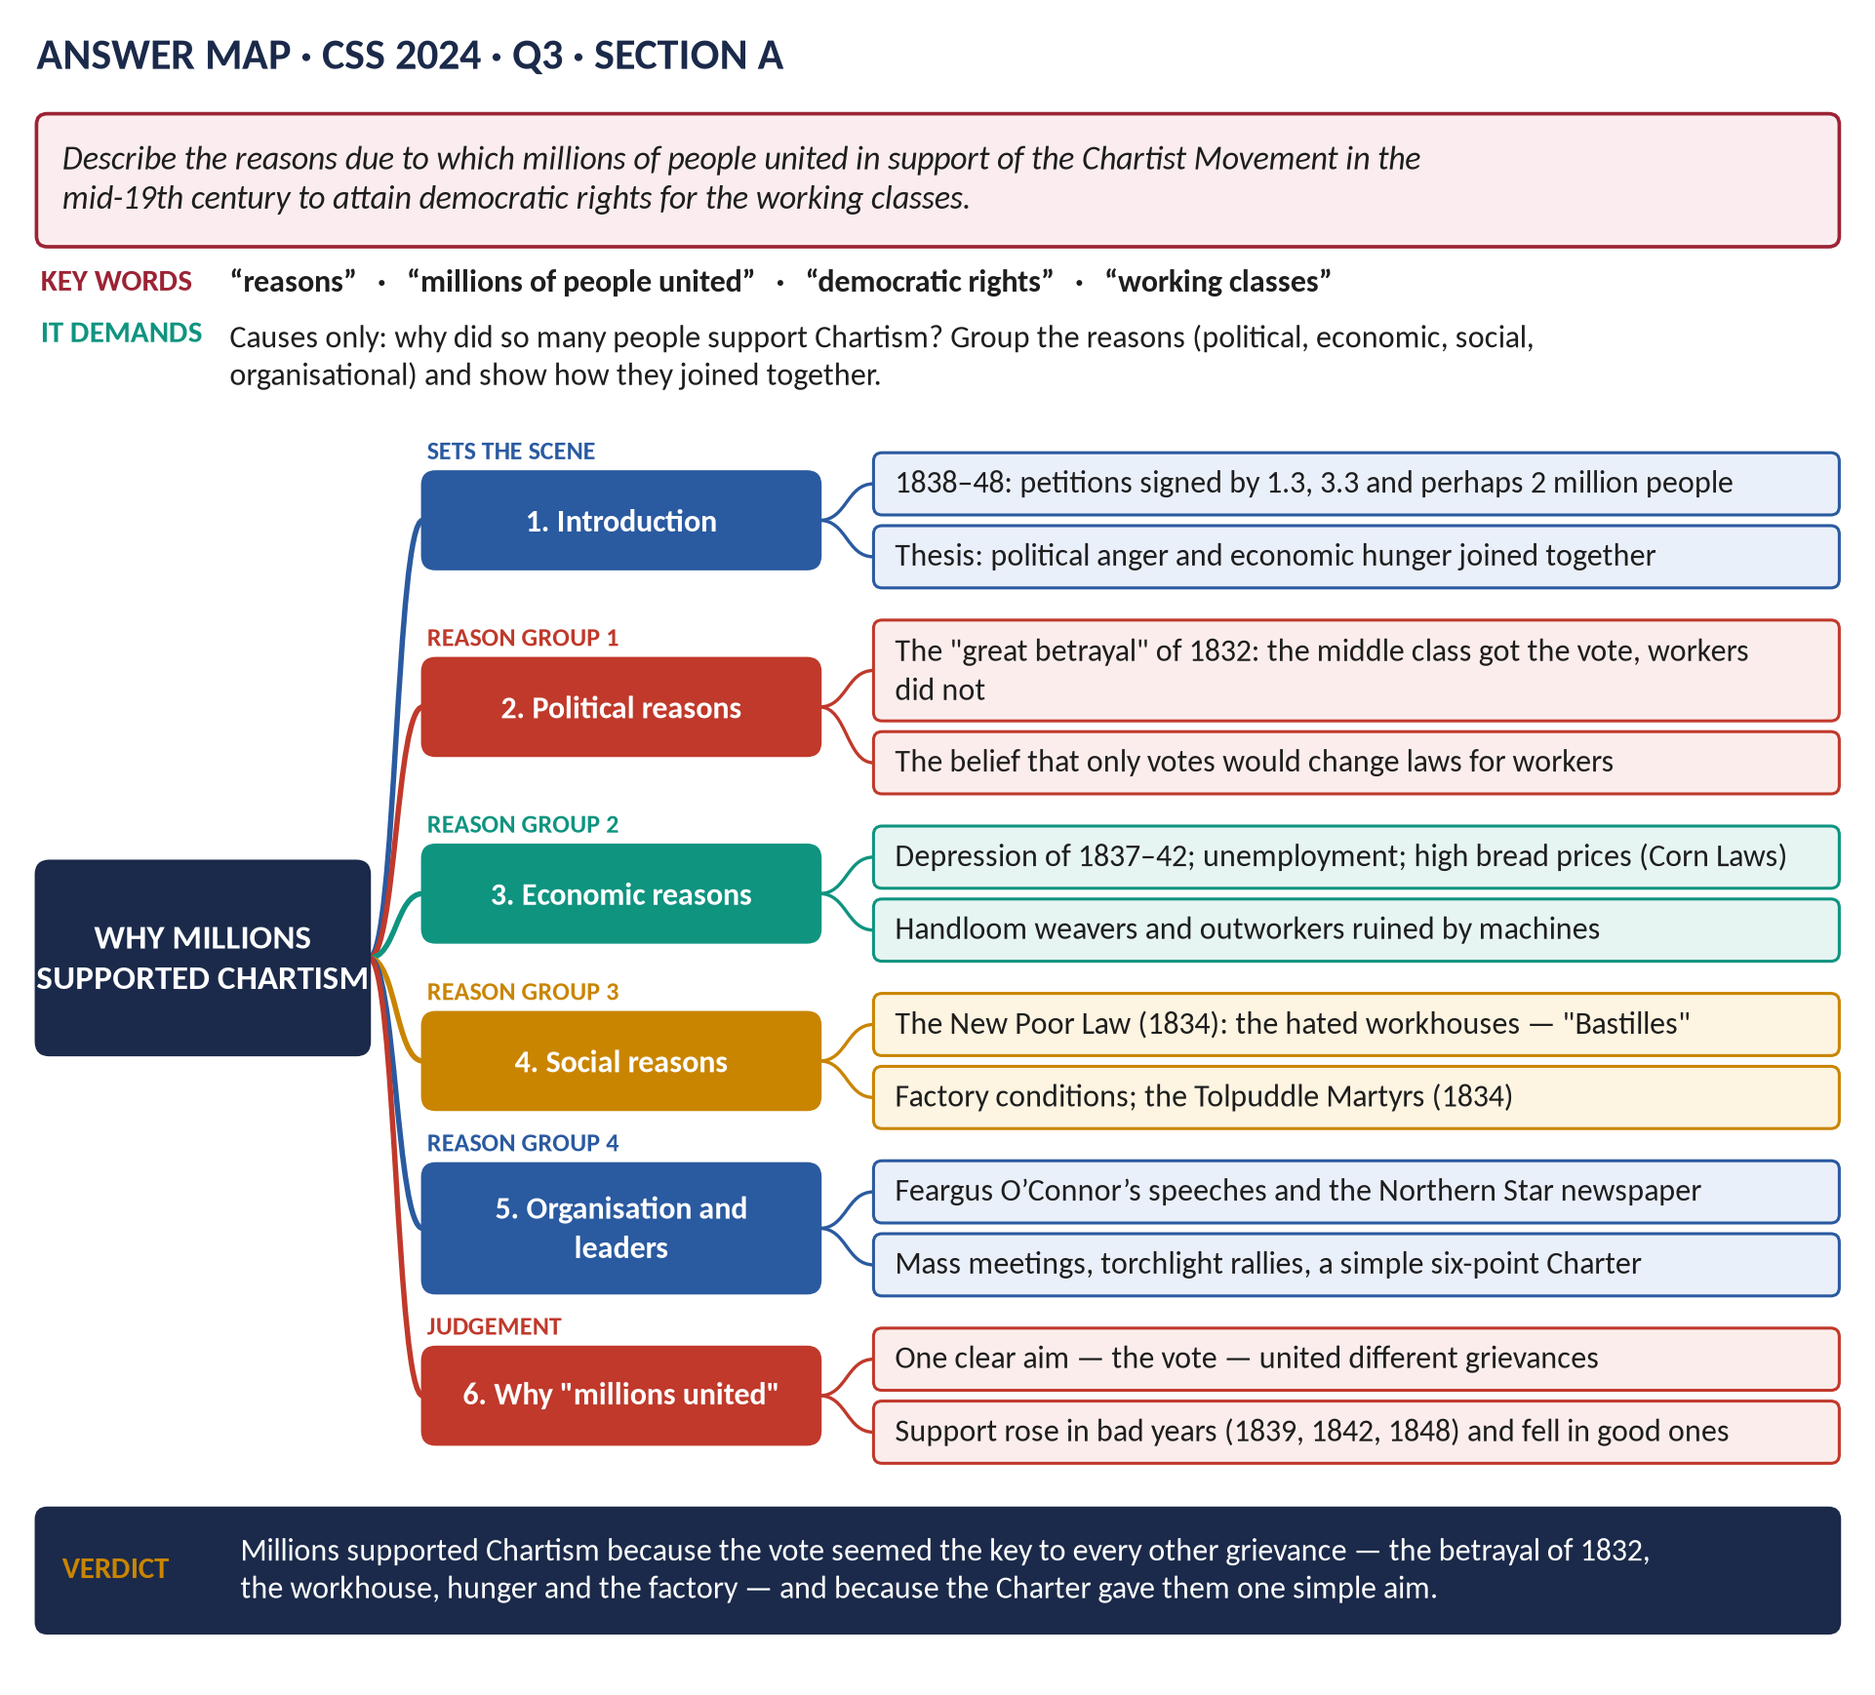
Figure 11 · The answer map for CSS 2024 · Q3 · Section A: every branch is one heading of the answer below.
DECODING THE QUESTION
A causes-only question. "Describe the reasons" = explain why so many people supported Chartism. "Millions united" — show why workers with different grievances joined one movement. "Democratic rights for the working classes" — the vote. Do not write about the failure — it was not asked.

The model answer

Introduction
Between 1838 and 1848 the Chartist petitions to Parliament were signed by about 1.3 million (1839), 3.3 million (1842) and perhaps 2 million (1848) people — at a time when the whole adult population of Britain was about 10 million. They wanted the People's Charter, above all the vote for every man. Millions united because political anger and economic hunger came together, and the Charter offered one simple remedy for all their grievances.

(1) Political reasons

(a) The "great betrayal" of 1832
Working men had marched and campaigned for the Reform Act of 1832. When it passed, it gave the vote only to middle-class men who owned or rented property worth £10 a year. Working men felt used and betrayed.

(b) The belief that the vote was the key
Workers reasoned: Parliament makes laws for those who elect it. If working men could vote, Parliament would make laws for working men — on wages, hours, bread and the Poor Law. The vote was the key to every other reform.

(c) The Whig government's harsh laws
The new, middle-class-elected Parliament seemed to act against the workers: the New Poor Law (1834) and the punishment of the Tolpuddle Martyrs (1834).

(2) Economic reasons
- The depression of 1837–42: factories closed, wages were cut, unemployment soared.
- Dear bread: the Corn Laws kept out cheaper foreign grain.
- Ruined craftsmen: handloom weavers and framework knitters, replaced by machines, were starving — they were among the most loyal Chartists.
KEY IDEA · "Knife-and-fork" Chartism
The Chartist leader J. R. Stephens said Chartism was "a knife-and-fork question" — a question of food. Support rose in the hungry years 1839, 1842 and 1848.

(3) Social reasons
- The New Poor Law (1834): the poor who needed help had to enter a workhouse, where husbands, wives and children were separated and conditions were made deliberately harsh. The poor called them "Bastilles". The anti-Poor Law movement in the north flowed straight into Chartism.
- Factory conditions: long hours, child labour, dangerous machines.
- Town life: slums, disease and no say in how towns were run.

(4) Organisation, leaders and the Charter
- The Charter itself: six short, clear demands, easy to understand and to sign.
- Feargus O'Connor: a powerful speaker who toured the country.
- *The Northern Star*** (1837): O'Connor's newspaper, read aloud in pubs and workshops, sold up to 50,000 copies a week.
- Mass meetings and torchlight processions made people feel part of something large.
- Local associations, the National Charter Association (1840) and a National Convention (1839).

(5) Why so many different people united
Group | Why they joined
Handloom weavers, knitters | Ruined by machines; wanted protection
Factory workers | Long hours, low pay; wanted the Ten Hours Bill
The unemployed and poor | Hated the workhouse
Skilled artisans (London) | Wanted political equality and education
Welsh miners and ironworkers | Harsh conditions (Newport Rising, 1839)

All their different grievances pointed to one answer: the vote. The Charter united them.
VERDICT · Conclusion
Millions of working people united behind Chartism because the betrayal of 1832, the hated workhouse, hunger and hard work all led to the same conclusion: only the vote would give them a Parliament that listened. The Charter turned many separate grievances into one simple demand for democratic rights.

WHY THIS ANSWER SCORES · Why this answer scores
It stays on reasons only · the reasons are grouped (political, economic, social, organisational) · it explains "millions united" with a table of different groups · figures (1.3m, 3.3m, £10) and a quotation (Stephens) add weight.

Answer 9 · Socialism and Liberalism in Nineteenth-Century Britain
THE QUESTION · CSS 2025 · Q5 · Section A · 20 marks
Compare and contrast the ideologies of Socialism and Liberalism in Britain during the 19th century, examining their differing approaches to issues such as economic inequality, social justice and the role of the state.

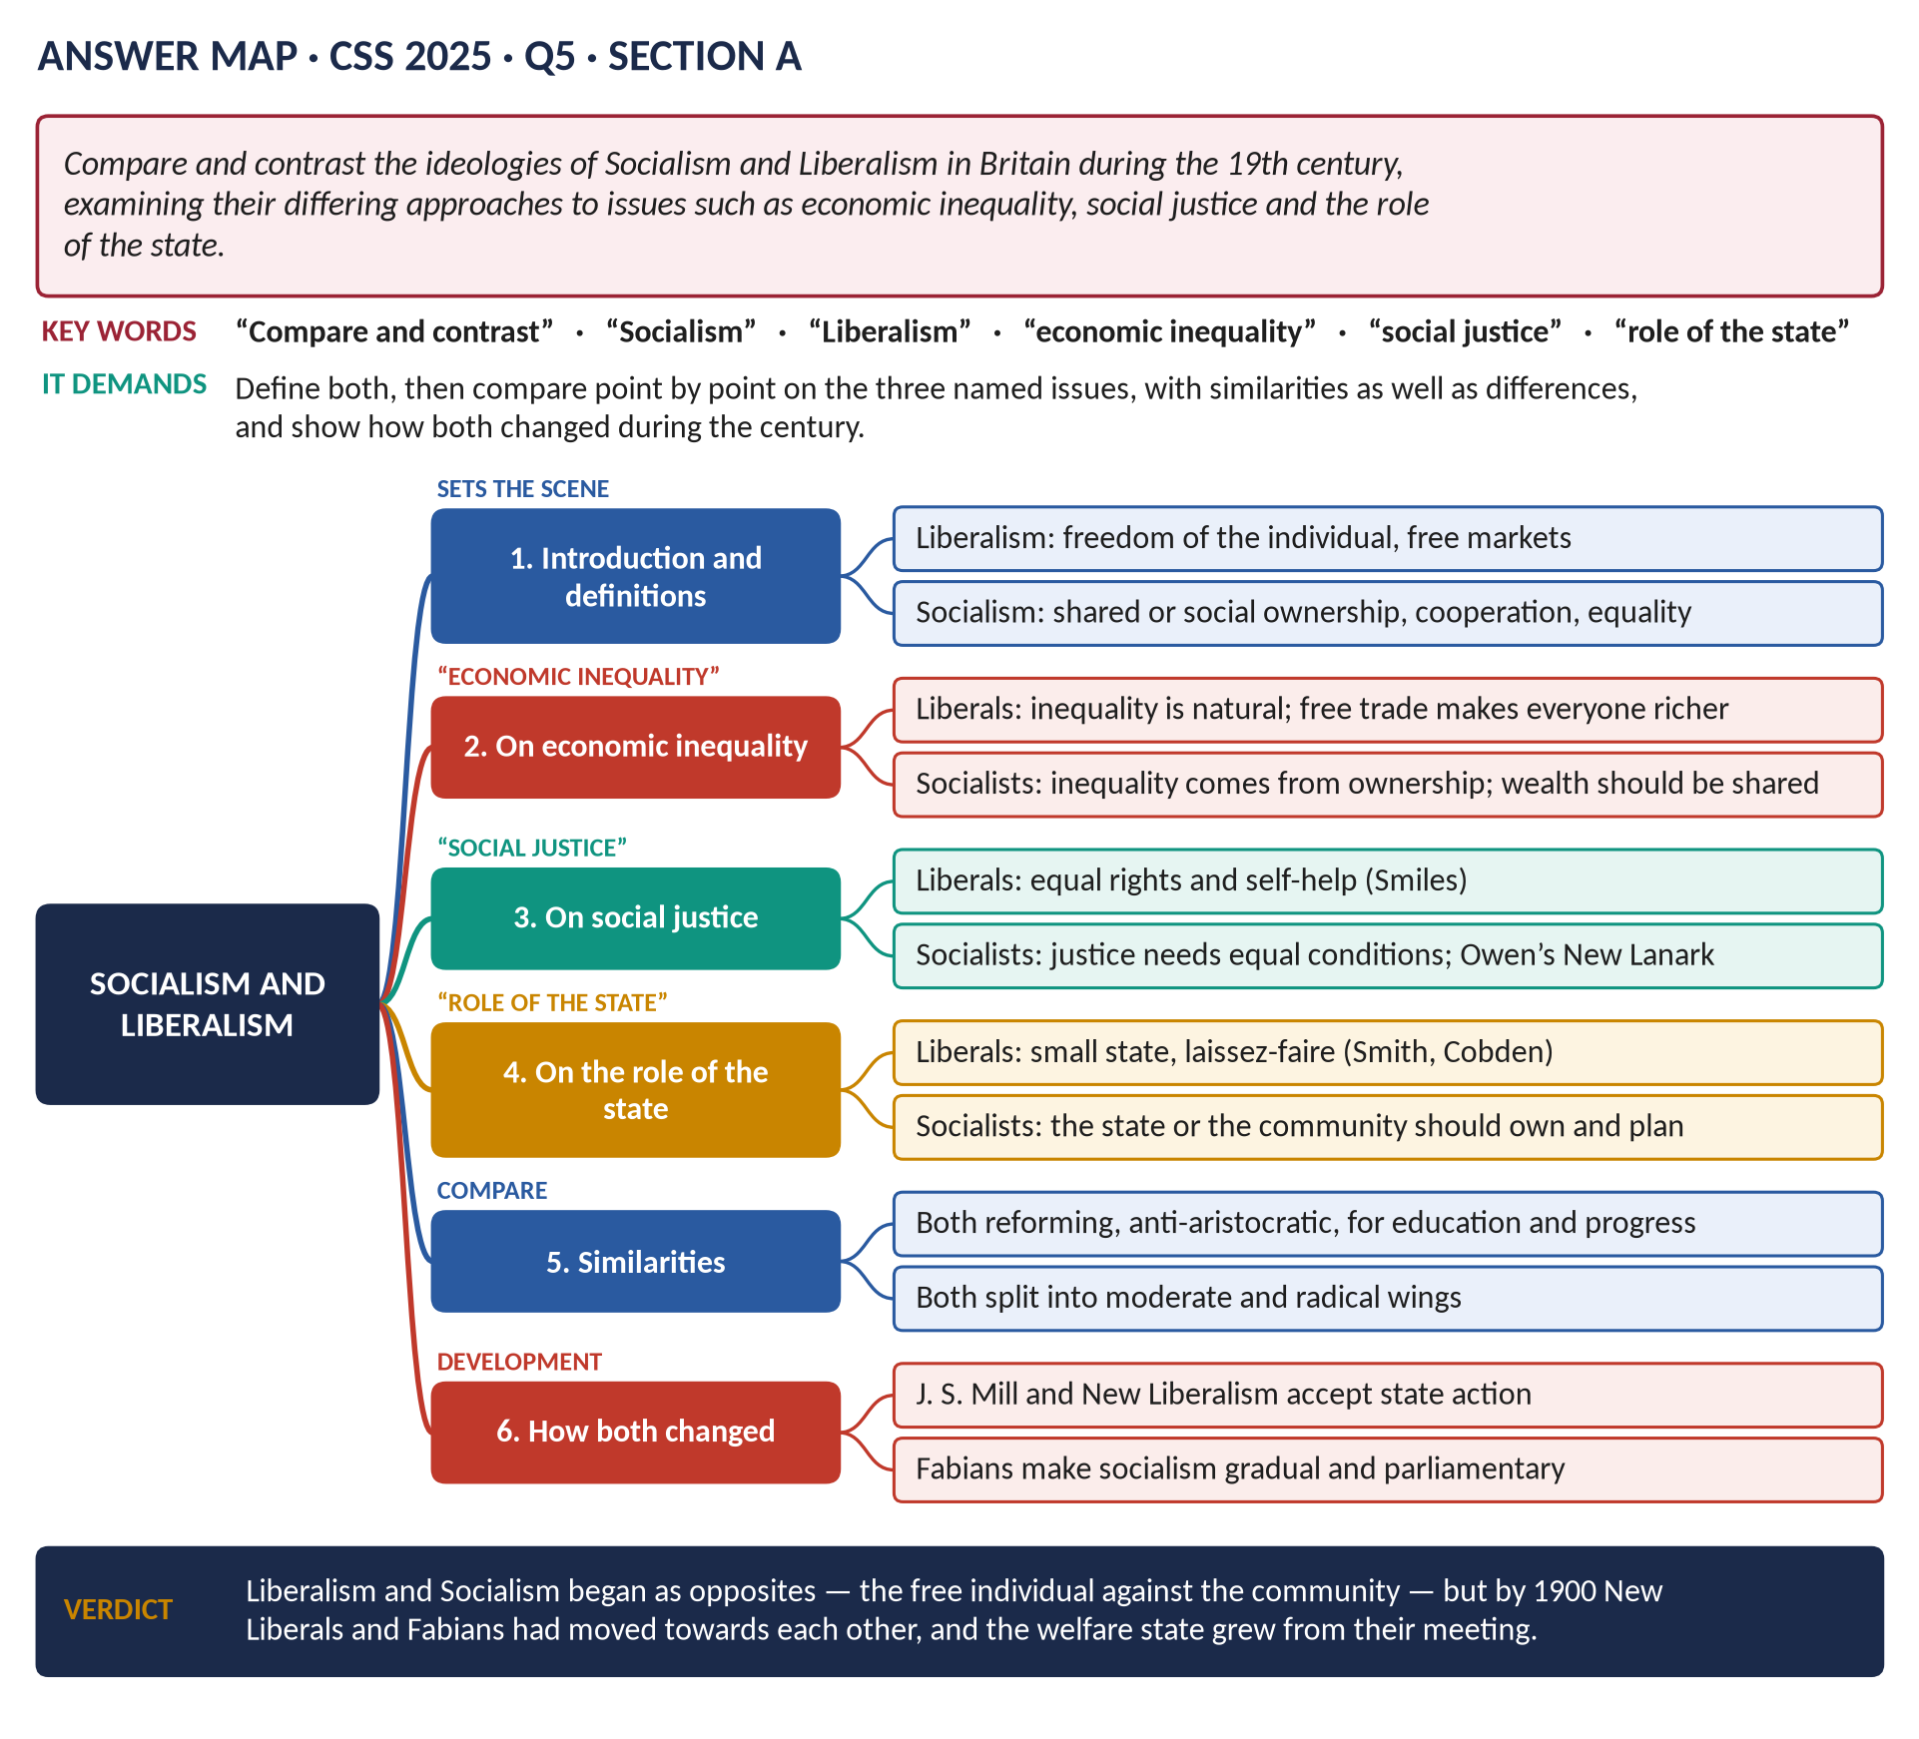
Figure 12 · The answer map for CSS 2025 · Q5 · Section A: every branch is one heading of the answer below.
DECODING THE QUESTION
"Compare and contrast" = show similarities and differences. The examiner names three issues — economic inequality, social justice, the role of the state — so each needs its own heading, with both ideologies side by side. An ideology is simply a connected set of ideas about how society should be run. Define both first, and show how both changed during the century.

The model answer

Introduction
The Industrial Revolution created a new society of factories, towns, great wealth and great poverty. Two sets of ideas — ideologies — offered opposite answers to the question "what should be done about it?" Liberalism put the free individual first: let people trade and work freely and everyone will become richer. Socialism put the community first: the workers who made the wealth should share it. They began as opposites, but by 1900 each had moved towards the other.
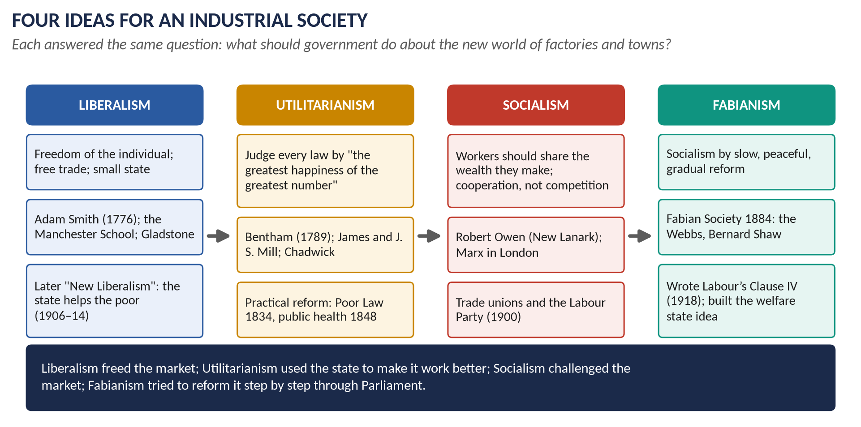
Figure 13 · Four ideas for an industrial society — Liberalism and Socialism, with Utilitarianism and Fabianism between them.

(1) What each ideology meant

(a) Liberalism
- Freedom of the individual — to think, speak, worship, trade and work.
- Free trade and laissez-faire ("let it be" — government should not interfere in business).
- Thinkers and leaders: Adam Smith (The Wealth of Nations, 1776), Richard Cobden and John Bright (the Manchester School), J. S. Mill (On Liberty, 1859), Gladstone.

(b) Socialism
- The community comes first; cooperation should replace competition.
- Land, factories and wealth should be owned in common or by the state, and shared fairly.
- Thinkers and leaders: Robert Owen (New Lanark), the co-operative movement (Rochdale, 1844), Karl Marx (who lived in London), the Fabians (1884), Keir Hardie.

(2) On economic inequality
Liberalism | Socialism
Inequality is natural and even useful: it rewards effort and talent and encourages hard work. | Inequality is unjust: it comes from a few people owning the land and factories while others own nothing.
Free trade and growth make everyone better off in the end — "a rising tide lifts all boats". | Growth under capitalism makes the owners richer and leaves the workers poor; wealth must be shared.
Example: the repeal of the Corn Laws (1846) to make bread cheaper. | Example: Owen's New Lanark showed that fair treatment and sharing could still be profitable.

(3) On social justice
Liberalism | Socialism
Justice means equal rights and equal opportunity — the same laws for all, religious freedom, open careers. | Justice means equal conditions — decent housing, work, health and education for everyone.
Self-help: individuals rise by their own effort (Samuel Smiles, Self-Help, 1859). | Mutual help: people rise together through unions, co-operatives and the community.
Poverty is often a personal failing; charity and the Poor Law are enough. | Poverty is caused by the system; it must be changed.

(4) On the role of the state
Liberalism | Socialism
A small state: keep order, defend the country, protect property and contracts. | A large state or community: own, plan and provide.
Laissez-faire: no interference in wages, prices or trade. | The state should control industry and protect workers.
Taxes low; spending small (Gladstone's "retrenchment"). | Taxes to pay for social services.

(5) Similarities
Despite their differences, the two ideologies shared much:
- Both were products of the Industrial Revolution and both claimed to speak for progress.
- Both opposed aristocratic privilege and wanted a wider vote.
- Both valued education and reason.
- Both mainly preferred peaceful, parliamentary change (except Marx).
- Both split into moderate and radical wings.

(6) How both changed — the meeting point
- Liberalism changed: J. S. Mill accepted that the state must sometimes act (education, factory laws); by the 1880s "New Liberals" such as T. H. Green argued that real freedom needs health, schooling and security — which only the state could provide. This led to the Liberal welfare reforms of 1906–14.
- Socialism changed: the Fabians (1884) rejected revolution and sought socialism gradually through Parliament — "the inevitability of gradualness". The Labour Party (1900) worked with the Liberals at first.
KEY IDEA · The meeting point
By 1900 New Liberals accepted state help for the poor, and Fabian socialists accepted gradual reform. The welfare state of the twentieth century was built on the ground where they met.

VERDICT · Conclusion
Nineteenth-century Liberalism and Socialism disagreed sharply: Liberals saw inequality as natural, justice as equal rights and the state as small; Socialists saw inequality as unjust, justice as equal conditions and the state as the community's tool. Yet both were reforming creeds born of industrial Britain, and by the century's end each had moved far enough towards the other to lay the foundations of the welfare state.

WHY THIS ANSWER SCORES · Why this answer scores
Definitions first · one heading for each of the three named issues, with the two ideologies side by side in tables · similarities as well as differences — which "compare and contrast" requires · names and dates for each point · the change over time gives a powerful conclusion.

Short Notes

The Industrial Revolution
THE QUESTION · CSS 2015 · Q8(a) · Paper I · short note (10 marks)
Write a short note on: Industrial Revolution

The Industrial Revolution was the change in Britain, between about 1750 and 1850, from making goods by hand at home (the domestic system) to making them by machine in factories (the factory system), powered by water, then by steam and coal. The phrase was made famous by Arnold Toynbee (1881).
- Causes: a growing population (8.9 million in 1801); the Agricultural Revolution; capital from trade and empire; coal and iron together; canals (1761) and railways (1830); stable government after 1688.
- Key inventions: Kay's flying shuttle (1733), Hargreaves's jenny (c.1764), Arkwright's water frame (1769), Watt's steam engine (1769), Crompton's mule (1779), Cartwright's power loom (1785); Darby's coke-smelted iron (1709).
- Effects: Britain became the "workshop of the world"; fast-growing towns (Manchester 75,000 → 300,000, 1801–51); slums and cholera; child labour and then Factory Acts (1833, 1847); a new middle class and working class; the Reform Act (1832) and Chartism; Methodism and new ideas.
- Debate: optimists (Ashton) v pessimists (Hobsbawm, Thompson).
In one line: it made Britain the first industrial nation and the richest in the world, at a heavy cost to the first generation of workers.

The Methodist Movement
THE QUESTION · CSS 2015 · Q8(b) · Paper I · short note (10 marks)
Write a short note on: Methodist Movement

Methodism was a Christian revival begun by John Wesley (1703–91), with his brother Charles and George Whitefield.
- Origins: the Holy Club at Oxford (1729), mocked as "Methodists" for their strict method; Wesley's conversion at Aldersgate Street on 24 May 1738 ("heart strangely warmed"); open-air preaching from 1739, first to the miners of Kingswood, Bristol.
- Why it spread: a neglectful Church of England; new industrial and mining areas without churches; a simple message that salvation is open to all.
- Organisation: classes of 12, societies, circuits, lay preachers, the annual Conference (1744); Charles Wesley's 6,000 hymns; Wesley rode 250,000 miles.
- Effects: sobriety, thrift and Sunday schools; working-class leaders trained for unions and Chartism; opposition to slavery. Critics: it taught the poor to accept their lot.
- Debate: Halévy — it saved England from revolution; Thompson — a "chiliasm of despair".
- Separation: it left the Church of England after Wesley's death (1791); 72,000 members then.

The Methodist Movement (set again)
THE QUESTION · CSS 2025 · Q8(b) · Section B · short note (10 marks)
Write a short note on: Methodist Movement

TRAP — DO NOT FALL INTO IT · The same short note, ten years later
2025 set exactly the same short note as 2015. Write the note above. To make it fresher, add one line on its legacy: Methodism became a worldwide church with tens of millions of members, and its chapels, Sunday schools and lay preachers helped shape the British Labour movement — it was said that Labour owed "more to Methodism than to Marx".

Fabianism
THE QUESTION · CSS 2016 · Q8(c) · Section B · short note (10 marks)
Write a short note on: Fabianism

Fabianism is the idea that socialism should come gradually and peacefully, through Parliament and reform, not through revolution.
- The Fabian Society was founded in London in January 1884.
- The name comes from the Roman general Quintus Fabius Maximus, "the Delayer", who defeated Hannibal by patience rather than one big battle.
- Leaders: Sidney and Beatrice Webb, George Bernard Shaw, Annie Besant, Graham Wallas; later H. G. Wells.
- Ideas: "the inevitability of gradualness" (Sidney Webb); public ownership of key industries; a national minimum of wages, health and education.
- Method: "permeation" — careful research and argument to persuade politicians and officials of all parties; the Fabian Essays in Socialism (1889).
- Achievements: a founding member of the Labour Party (1900); founded the London School of Economics (1895) and the New Statesman (1913); Sidney Webb wrote Labour's Clause IV (1918); Beatrice Webb's Minority Report (1909) foreshadowed the welfare state.
In one line: Fabianism made British socialism gradual, practical and parliamentary — the path the Labour Party followed.

Utilitarianism
THE QUESTION · CSS 2022 · Q8(c) · Section B · short note (10 marks)
Write a short note on: Utilitarianism

Utilitarianism is the theory that every law, institution and action should be judged by one test: does it produce "the greatest happiness of the greatest number"?
- Founder: Jeremy Bentham (1748–1832), An Introduction to the Principles of Morals and Legislation (1789). Pleasure is good and pain is bad; a good law increases happiness and reduces pain.
- Method: rational, scientific government — inquiries, statistics, inspectors. Bentham designed the Panopticon, a model prison.
- Followers: James Mill, John Stuart Mill (Utilitarianism, 1863), and the "Philosophic Radicals".
- Influence on reform: Edwin Chadwick, Bentham's secretary, shaped the New Poor Law (1834) and the Public Health Act (1848); Utilitarian ideas influenced the Reform Act of 1832, prison and legal reform, and the modern civil service.
- Criticism: it could be cold and mechanical — the workhouse was "efficient" but cruel; Dickens mocked it in Hard Times (Mr Gradgrind); J. S. Mill added that some pleasures are higher than others.
In one line: Utilitarianism gave nineteenth-century reformers a simple test for every law, and helped build the modern, active British state.

Part Two — The Past MCQs, Solved

CSS 2025 · MCQ 6
Which religious movement emphasised personal piety and social reform?
(A) Puritanism | (B) Anglicanism | (C) Methodism | (D) None of these

REMEMBER · Answer: C. Methodism
Methodism, founded by John Wesley from 1738, stressed personal piety (a changed, holy life) and social reform — Sunday schools, care for the poor and prisoners, opposition to slavery.

CSS 2025 · MCQ 7
What was the main political demand of the Chartists?
(A) Women's suffrage | (B) Universal male suffrage | (C) Free trade | (D) None of these

REMEMBER · Answer: B. Universal male suffrage
The Chartists' central demand was universal male suffrage — the vote for every man over 21 — the first of the six points of the People's Charter (1838).

Part Three — Five Predicted Questions, with Outlines
WHAT THE EXAMINER HAS ASKED · Why these five
They cover the parts of syllabus Head VII that have not yet been set as full questions, or angles the examiner is likely to try next.

Predicted 1 · "Discuss the causes and consequences of the Agricultural Revolution in England."
- Introduction: open fields → enclosed farms; thesis: it fed the Industrial Revolution but hurt the cottager.
- Causes: growing population and demand; high grain prices (French wars); new ideas (Tull, Townshend, Bakewell, Coke, Young); private Enclosure Acts (about 4,000).
- Consequences: more food; bigger farms; richer landlords; capital and labour for industry; loss of the common; landless labourers; Swing Riots (1830).
- Verdict: economically a great success; socially painful for the rural poor.

Predicted 2 · "Why did the British state begin to intervene in factories and towns in the first half of the 19th century?"
- Introduction: from laissez-faire to inspection and regulation.
- Reasons: the evidence of reports (Sadler 1832, Chadwick 1842); campaigners (Lord Shaftesbury, Richard Oastler); cholera fear; Utilitarian ideas; Tory paternalism; pressure from Chartism and workers.
- Measures: Factory Acts 1833, 1844, 1847; Mines Act 1842; Public Health Act 1848.
- Verdict: humanity, fear and new ideas combined; intervention was still limited before 1870.

Predicted 3 · "Assess the influence of Utilitarianism on nineteenth-century British reform."
- Introduction: Bentham's "greatest happiness" test.
- Influence: New Poor Law 1834 (Chadwick); public health 1848; law and prison reform; the Reform Act 1832; civil-service reform.
- Limits: Tory paternalism, evangelical religion and working-class pressure mattered too; Utilitarian reforms could be harsh (the workhouse).
- Verdict: it gave reform its method and much of its machinery, but not its heart.

Predicted 4 · "Trace the growth of trade unionism in Britain from the Combination Acts to the formation of the Labour Party."
- Stages: Combination Acts (1799–1800) → legal 1824; Owen's GNCTU and Tolpuddle (1834); "new model" unions of skilled workers (1850s, ASE 1851); TUC 1868; legal protection (1871, 1875); New Unionism of the unskilled (match girls 1888, dockers 1889); Labour Representation Committee (1900).
- Verdict: from illegal conspiracy to political party in a century.

Predicted 5 · "'Methodism saved England from revolution.' Discuss."
- For (Halévy): turned discontent into religion; taught order, thrift and obedience; Wesley a Tory who opposed rebellion.
- Against: other reasons — reform, repression, economic growth, the British constitution; Methodists often led protest (Tolpuddle, Chartism, miners' unions); Thompson: "social control", not salvation.
- Verdict: Methodism helped channel discontent peacefully, but it was one factor among many, and it also trained the leaders of peaceful protest.

